Participate Effectively in WHS Communication and Consultative Processes
BSBWHS304

Computer Training Manual
for ICT Information, Digital Media and Technology

Copyright Information
PO Box 15062
City East, Brisbane QLD 4000
Ph 1300 309 744
Fax (07) 3229 1254
manuals@datadiscovery.com.au
www.datadiscovery.com.au


BSBWHS304
Author: Paul Watson
© Data Discovery 2012
Version 1: February 2012

This manual is copyright. No part of this manual may be reproduced or transmitted in any form or by any means, electronic or mechanical, including photocopying, recording, or by any information storage and retrieval system, without the written permission of Data Discovery.

You have three options when purchasing these manuals:
1. Purchase a single copy for each user, a class set or a copy for each computer
2. Purchase a paper Site Licence for making unlimited copies of this manual
3. Purchase a Copyright licence to alter the contents of the manual

Class sets of these training manuals are available.
Do not purchase one manual and make your own copies. You have not been given permission to copy even a part of this manual.

The software used in the production of this manual was Microsoft Word 2010, Microsoft Windows 7 and SnagIt 10.
Microsoft®, Microsoft® Windows™, Microsoft® Word for Windows™, Microsoft® Excel for Windows™, Microsoft® PowerPoint™, Microsoft® Access for Windows™, Microsoft® Publisher™, Microsoft® Outlook are registered trademarks of Microsoft Corporation.

All information is correct to the best of the author’s knowledge. The author has made every attempt to ensure accuracy but cannot be held responsible for any loss or damage arising from any information contained or implied in this publication.

Data Discovery
PO Box 15062
City East, Brisbane Q 4002

Ph: 1300 309 744
Fax: (07) 3229 1254
email: manuals@datadiscovery.com.au
website: www.datadiscovery.com.au

Table of Contents
Introduction i
Elements of Competency ii
Employability Skills Summary iv
Table of Contents vi
Safety in the Workplace 1
WHS Legislations 3
Duty of Care 5
Consultative WHS Processes 8
WHS Barriers 8
WHS Representatives 10
WHS Meetings 17
WHS Consultations 21
Managing WHS Information 25
Managing Workplace Safety 29
Risk Assessments 30
Near Miss 39
Fire and Evacuation 42
Accident Reporting 47
Injury/Incident Register 50

Safety in the Workplace
Every year in Australia, thousands of Australian workers are injured in the workplace causing great inconvenience to themselves, their families and their employers. Some are injured so severely that they are no longer able to work, and in extreme cases, some are killed.
In 2009-10, approximately 53 people experienced a work-related injury or illness per 1,000 people who had worked at some time during that period. Sprains/strains were the most commonly reported work-related injury sustained across the majority of industries, followed by cuts/open wounds and chronic joint or muscle conditions.
Of the 640,700 people who experienced a work-related injury or illness, 27% (175,000) sustained their injury through lifting, pushing or pulling an object, 25% (157,300) by hitting, being hit or cut by an object, 13% (84,700) through falls on the same level and 8% (50,200) through repetitive movements.
Of the 640,700 people who experienced a work-related injury or illness:
- 56% had some time off work (54% of men and 57% of women). Approximately 7% took part of a day or shift and 22% took one to four days off (22% of both men and women);
- 24% had 5 days or more off work and 3% had not returned to work since the injury or illness occurred;
- 45% did not have any time off. The injuries or illnesses most often experienced by this group were sprains and strains (31%) and cuts/open wounds (20%); and
- 12% were no longer working in the job in which the work-related injury or illness occurred. Of these, 38% left because of their workplace injury or illness.

Sourced directly from the Australian Bureau of Statistics: www.abs.gov.au

In an effort to combat this, each state and territory in Australia has strict Work Health Safety(WHS) Acts in place to legislate, advise and monitor WHS processes in the workplace. The purpose of Work Health Safetylegislation is to prevent workplace injury and illness by encouraging and enforcing the provisions of safe and healthy working environments.

Exercise 1

- Have you, or any workmates ever suffered an injury in your workplace (no matter how small)?

- What was the outcome of the injury?

- Where any changes made to processes within the workplace as a result of this injury?

WHS Legislations
Under the current system of government in Australia, States and Territories have responsibility for the management of workplace health and safety Legislations and Acts. Each staff member should be familiar with the Work Health SafetyAct relevant to their state or territory.

Although subtly different, each Act is designed to provide a broad flexible framework that involves employees, employers and their representative (unions and employer associations etc.) in formulating and implementing health and safety standards. The aim of the law is to improve workplace health and safety, although it does not provide prescribed standards for specific hazards.

National Bodies

WorkSafe Australia
Workplace Safety Australia was created in the year 2000 and is a leading National WHS advisory and information provider to Australian companies. Website: www.worksafe.com.au
Safe Work Australia
Safe Work Australia began in November 2009 and operates as an independent statutory agency with primary responsibility to improve work health and safety and workers’ compensation arrangements across Australia. Website: www.safeworkaustralia.gov.au

State Bodies

Australian Capital Territory | WorkSafe ACT www.worksafe.act.gov.au/health_safety
Northern Territory | NT WorkSafe www.worksafe.nt.gov.au
Queensland | Workplace Health and Safety QLD www.whs.qld.gov.au
South Australia | WorkSafeSA www.safework.sa.gov.au
Tasmania | Work Place Standards Tasmania  www.wst.tas.gov.au
New South Wales | WorkCover NSW www.workcover.nsw.gov.au
Victoria | WorkSafe Victoria www.worksafe.vic.gov.au
Western Australia | WorkSafe WA www.safetyline.wa.gov.au

Exercise 2

Undertake some research on the Internet and locate the WHS governing body for your state.
- Locate three points of information on the site that have direct implications to your workplace. Discuss these.

Duty of Care
One of the main aspects of the WHS legislation of all state and national bodies revolves around duty of care. Duty of care requires everything “reasonably practicable” to be done to protect the health and safety of others at the workplace. The Model Work Health and Safety Bill of June 2011 outlines duty of care as:

A person conducting a business or undertaking must ensure, so far as is reasonably practicable, the health and safety of:
(a) workers engaged, or caused to be engaged by the person; and
(b) workers whose activities in carrying out work are influenced or directed by the person,
while the workers are at work in the business or undertaking.
Source: http://www.safeworkaustralia.gov.au

This duty is placed on:
- all employers
- their employees
- any others who have an influence on the hazards in a workplace

The last point includes contractors and those who design, manufacture, import, supply or install plant, equipment (including computers) or materials used in the workplace.

The Duty of care places a requirement on employers to provide:
- A working environment that is safe and without risks to the health of employees.
- Adequate training, information and supervision to ensure the health and safety of employees.
- Processes for consultation over Work Health Safetyas set out in legislation.

Employees also have a duty of care in relation to workplace safety. Generally, they must perform all duties in a manner that ensures their health and safety and that of others in the workplace to the extent to that they are capable of doing so.

The relevant State and Territory or Commonwealth Work Health Safetyact should be consulted to ascertain the exact duties set down for employers and employees. There are severe penalties in place for employers and employees who fail to meet and maintain these duties.

Duties of Employers

Employers have a duty as is practicable, to their employees, independent contractors and visitors to:
- Provide and maintain a safe and healthy working environment (including safety equipment).
- Ensure that the use, handling, storage and transport of plant and substances is safe and without risk to health.
- Provide facilities for the welfare of employees.
- Provide information, instruction, training and supervisions as necessary to enable employees to work safely and without risks to health.

An employer is also required, so far is practicable to:
- Maintain the health of the employees.
- Monitor conditions at the workplace.
- Maintain health and safety records of employees at the workplace.
- Engage suitably qualified persons in Work Health Safetyto provide appropriate advice.
- Nominate a person with an appropriate level of seniority to be the employer’s representative.
- Provide information in appropriate languages.

Duties of Employees

While at work, an employee must:
      - Work safely and use equipment in a safe manner.
      - Take reasonable care for his or her own health and safety and for health and safety of anyone else who may be affected by his or her acts or omissions at the workplace.
      - Cooperate with his or her employer with respect to any action taken by the employer to comply with any requirement imposed by or under this Act.

An employee shall not:
- Wilfully or recklessly interfere with or misuse anything provided in the interests of health safety or welfare in pursuance of any provision of the Act or the regulations.
- Wilfully place at risk the health and safety of any person at the workplace.

It is imperative that all workers follow workplace safety procedures, and it is also a legal requirement that the procedures be issued to each worker. Let us have a look at several types of areas that can require safety procedures.

Exercise 3
- Refer to the WHS legislation site that you identified in Exercise 2. Discuss any information in regards to duty of care that you can locate.

Consultative WHS Processes
In the previous section of this manual we discovered some of the WHS requirements that influence the workplace including Legislations and duty of care. Duty of care guidelines stipulate that WHS is the responsibility of both the employer and employee. In order to maintain these requirements, there needs to be complete input and feedback from all members of the workplace as a consultative process. In most cases, this consultative process is managed by an WHS Representative or Committee.

WHS Barriers
In the next sections of this manual, we will examine the points surrounding the identification and appointment of an WHS representative and committee. As we discuss their requirements and processes, we must always consider the influences and disruptions that can be experienced by WHS barriers. WHS barriers can be considered as any process, attitude or behaviour that directly causes a safety risk within the workplace. These barriers can be caused by the WHS committee, management or workplace team members and can include:

- Low level of commitment to WHS processes
- Cost
- Shortcuts taken due to workplace requirements
- Lack of training and supervision
- Lack of/poor consultation with employees
- Lack of understanding of expectations and needs
- Invalid signage
- Lack of care by employers and/or employees
- Staff disinterest

Luckily for us, most of the processes we will cover throughout this manual are aimed at reducing these including:

- Increasing management commitment via WHS committees
- Consultation
- Appointment of work based representatives

Exercise 4
- Discuss some of the WHS barriers that may be evident within your workplace.

- Are there any processes within the workplace that you are aware of to overcome these barriers?

WHS Representatives
According to the Work Health SafetyAct 2000, an WHS representative is to be elected for the purposes of consultation if at least one of the persons employed by the employer requests the election of the representative or if WorkCover so directs. The employees may elect more than one WHS representative if the employer agrees or if WorkCover so directs.

The WHS representative must then:
- Form WHS committees, deputies and workplace section representatives
- Organise and manage WHS committee meetings
- Undertake applicable internal and external consultation processes
- Maintain and distribute WHS information to workplace
- Manage WHS barriers
Source: www.workcover.nsw.gov.au

WHS Committees

According to the Work Health SafetyAct 2000, an employer must establish an WHS committee if they employ more than 20 staff members on a full time, part time, contract or casual basis and are requested to do so by the employees or directed by their state WHS body. In the case where there are 10 or more, but less than 20 employees employed at the workplace they may elect an employee to be a safety representative for that workplace.

The main functions of an WHS committee are to facilitate discussion and consultation with the employer, employees and if required, national WHS bodies.

The key roles of an WHS committee are numerous and can include:

- Identification and appointment of workplace safety and inspection officers.
- Providing advice and recommendations in regards to rules and procedures relating to the health and safety of persons within the workplace.
- Making recommendations in regards to the establishment of PH&S programs including induction, refresher and tasks specific information and training programs.
- Reporting on the current WHS status of the workplace.
- Management of legislated requirements such as the WHS White Card.
- Management of ongoing WHS audit requirements such as hazard inspections, risk analysis and workplace maintenance.
- Undertaking measures to ensure that the workplace is compliant with the WHS legislations within their state or territory.
- Identifying and overcoming any issues or barriers hindering the implementation of identified WHS processes.

As part of their commitments, all members of the WHS committee are normally required to undertake formal training to ensure that they are knowledgeable in all aspects relating to their industry and state. They are also required to ensure that they are kept abreast of any changes to WHS acts and legislations.

Forming the Committee
The WHS committee is generally made up of elected employees working at the workplace. It can however, at the request of the employer, also contain an external representative such as:
- An industry expert
- An WHS specialist
- A representative of the business owner

There is no legislated set number of employees that can comprise an WHS committee although unless otherwise agreed between the employer and employees, generally not less than half of the members of the committee are to be employed at the workplace.

There are also a number of ways that an WHS committee can be formed. In larger companies, WHS representatives and even committees are formally employed to manage WHS processes. In most cases however, the WHS committee is installed by way of employee vote. The examples of the following pages are from the WHS Committee Election Kit published by SafeWork SA.
Sources: www.austlii.org, www.safework.sa.gov.au

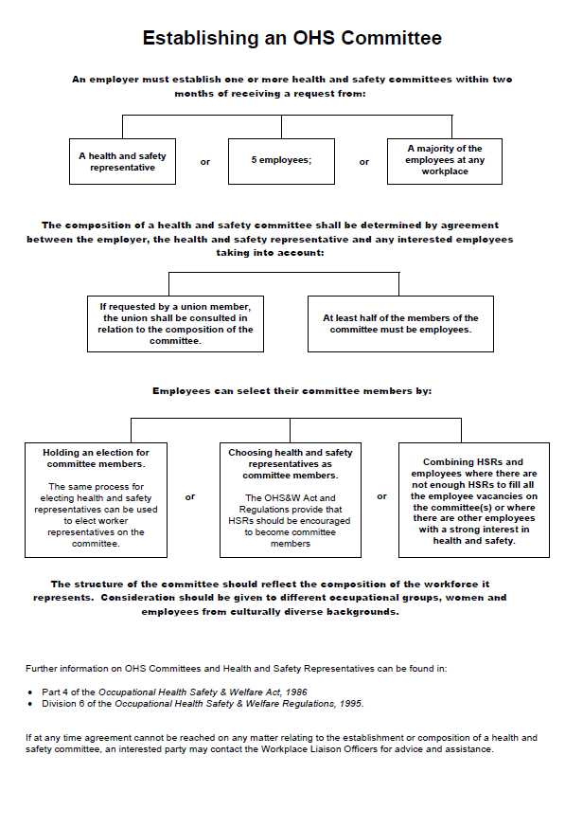

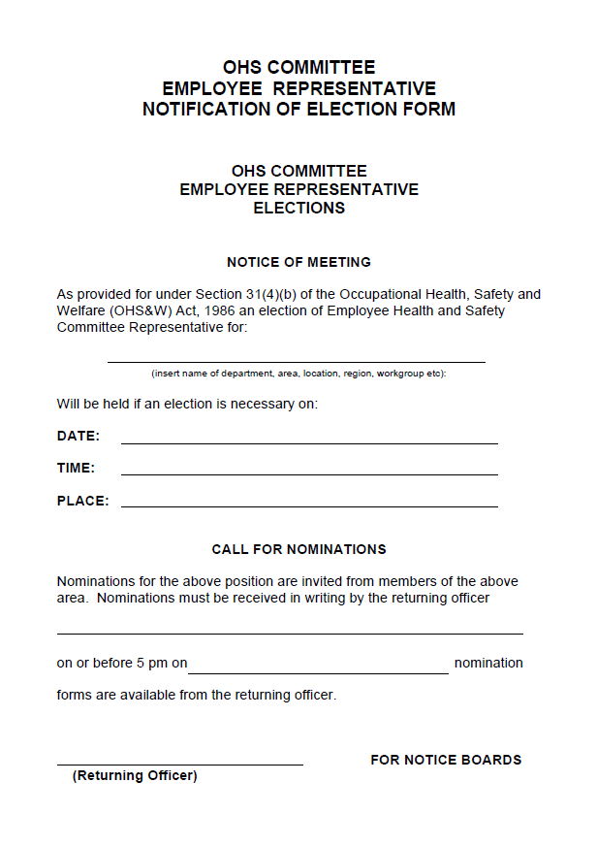

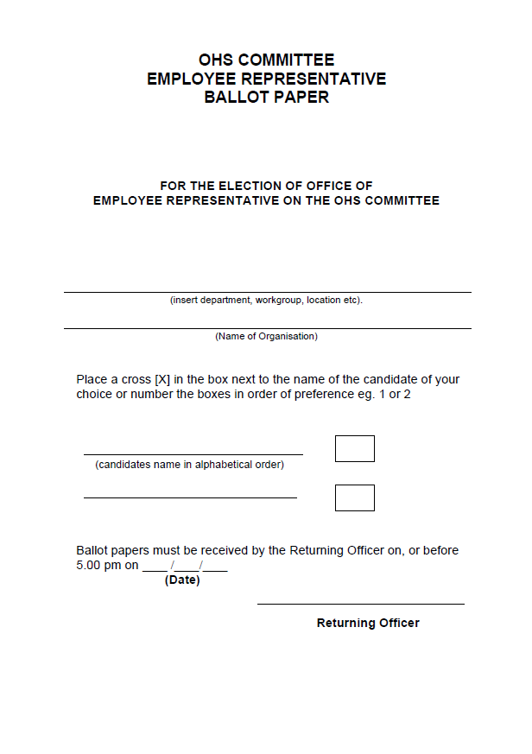
Exercise 5
- Who is responsible for maintaining WHS standards and behaviours within your workplace (careful, is this a trick question)?

- Who is the WHS representative within your workplace?

- Does your workplace maintain a working WHS committee?

- Discuss how this committee was formed.

- What is the composition of the this committee (who sits on it?).

- Discuss the functions that are performed by your WHS committee.

WHS Meetings
Due to its importance and influence within the workplace, it is imperative that WHS meetings are run formally and effectively. Some tips to running effective meetings include:
- Send formal invitations to all members
- Create and distribute an agenda before the meeting
- Locate and provide supporting documentation (normally distributed with the agenda)
- Assign a meeting chair
- Stick to timeframes
- Keep discussions on topic as much as possible
- Finish on time

One of the WHS barriers we discussed earlier was a lack of management or committee input. Committee members will be more likely to attend and contribute should these meetings be run efficiently and not gain the perception of being a waste of time. Personalities must be managed to ensure that all members are able to speak, listen and pass opinions as required.

Team Member Responsibilities
Just because a meeting is managed as required, it does not necessarily mean that it will be able to meet its requirements. All members must, by accepting their nomination and position adhere to the responsibilities of their tenure as a part of the committee. These responsibilities include:
- Attend scheduled meetings - or send apologies or a proxy if available.
- Ensure that they are familiar with the agenda and/or supporting documentation such as minutes from previous meetings.
- Give each meeting their full attention.
- Provide advice as required.
- Ensure familiarity with subject matter relevant to their own work areas.
- Distribute information as relevant to relevant work areas.

The example on the next page is of a sample meeting agenda provided by WorkSafeSA SA.

Source: www.safework.sa.gov.au

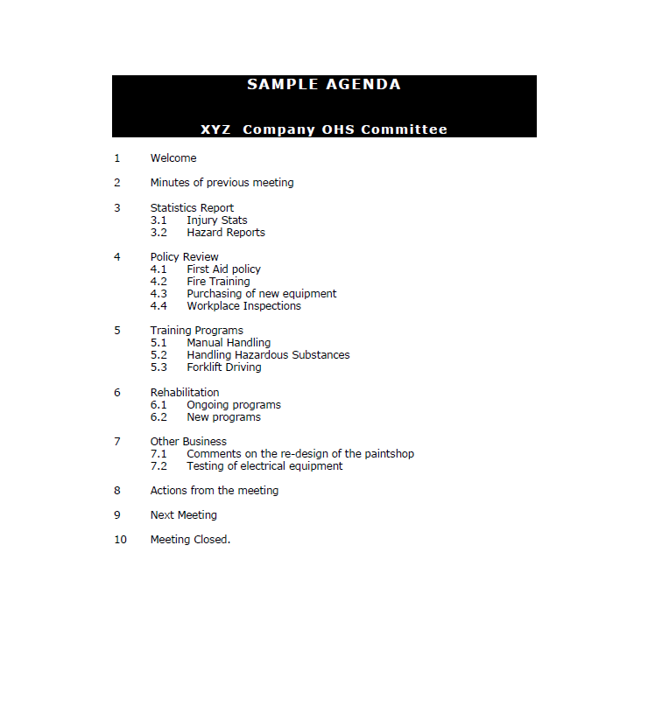

Exercise 6
- Discuss your experiences attending formal meetings. What processes were followed?

- Refer to the WHS legislation site that you identified in Exercise 2. Discuss any information in regards to running WHS committee meetings that you can locate.

- Use the space below to create an agenda that could be utilised within an WHS committee meeting within your workplace.

WHS Consultations
As we have discussed, one of requirements of WHS committee representatives is to report on the current WHS status of the company or workplace. In order to acquire this information, individual members of the committee are often assigned positions within the workplace. These tasks include:

Safety Officer | Safety officers are trained members of the staff who perform the day to day tasks associated with WHS such as:  - Organising training  - Holding workplace meetings  - Investigating accidents and near misses  - Providing first aid  - Undertaking risk assessments  - Maintaining WHS Documentation  In some cases, the WHS safety officer is employed in a full time position reporting to the WHS committee.
Workplace Trainer | The workplace trainer (often the Safety Officer) is an officer utilised within the organisation to undertake any training required by staff members. The workplace trainer will generally hold WHS qualifications and be fully conversant with current legislations and the tasks carried out within the workplace.
Inspection Officer | The role of the Inspection officer is to undertake scheduled and random checks of the workplace in an effort to identify area of hazard or risk. They will also identify any maintenance issues (loss of safety signs or equipment in need of repair etc.). See the Managing Workplace Safety section of this manual for more information in regards to workplace inspections.

WHS Inspectors | Each state or territory governing body appoints inspectors to enforce company WHS requirements and legislations. These inspectors can visit a workplace under appointment, after an accident or at random to:  - Undertake checks for adherence to WHS legislations  - Provide WHS advice  - Mediate WHS disputes  - Complete accident reports  In some states, WHS Inspectors also have the power to issue warnings, fines or even instigate workplace shutdown procedures.

This table highlights some of the consultation processes that can be undertake by various delegated members of the committee. The main purpose of these processes is to gather the information to allow the committee to make decisions and recommend improvements effectively. At the end of the day, no person is more readily available to provide up to date information in regards to the safety of a particular area than the person who is working within it. These consultation processes allow for this knowledge to be gathered.

Reporting WHS Issues
It is also the responsibility of all workplace staff members to report WHS issues as they arise in order to reduce the chance of injury or illness. In many cases, these issues are reported to the WHS representative via:
- WHS reporting form (hazards, risks, accident reporting forms etc. – see next section of this manual)
- Workplace meetings
- WHS training sessions

Workplace Meetings

The purpose of WHS workplace meetings is twofold:
- To disseminate information such as improved practices, WHS legislation updates or requirements, identified hazards or risks and future training courses etc. from the committee to the workforce.
- To allow the workforce to raise or highlight issues that relate to their own work areas.
- Maintain ongoing staff interest and support.

Workplace meetings are generally informal proceedings that allow staff members to mingle and discuss information as required. It is critical however, that information raised is reported to and acknowledged or acted upon by the WHS committee. Failure to do so will compromise the process of gaining accurate information from the workplace at future meetings.
Training Sessions

Training sessions are most often carried out in areas (such as construction and mining) where there is a legislated training requirement in place. In these cases, staff members are required to attend mandatory training in regards to WHS within their workplaces. Other companies hold training courses as a means of ensuring that all members of the work team are able to complete their requirements safely within workplace policies and procedures.

The following is an example of the information covered within a Queensland WHS Construction White Card training course:
- Basic information on the Workplace Health and Safety Act 1995 , Workplace Health and Safety Regulation 2008 and codes of practice
- Risk management
- Principal contractor’s safety plan
- Work method statements
- Material safety data sheets
- Basic emergency procedures such as first aid, evacuation plans and procedures
- Causes of fires and types of controls
- Reporting hazards to relevant persons at the workplace
- Obligations of principal contractors, employers, self-employed persons, workers and others
- Workplace Health and Safety Officers
- Duty of care under common law
- Workplace recording of work injuries, work caused illnesses and dangerous events.
Source: www.whitecardonline.com.au

Training courses are usually more formal than workplace meetings and do not normally allow for the reporting of the current WHS status of the workplace.

Exercise 7
- Discuss the WHS consultation roles within your workplace and the processes they utilise to deliver and gather information

- Refer to the WHS legislation site that you identified in Exercise 2. Discuss any mandatory training programs that may be required within your industry.

- Discuss any external inspectors of officers that may visit your workplace. What tasks do they perform?

Managing WHS Information
The management of documentation is another task often carried out by the Safety officer and an extremely effective means of ensuring WHS information is available to team members. WHS documentation is critical to the ongoing prevention, identification, reporting and analysis of potential dangers in the workplace. The safety officer is required to ensure that any documentation to do with workplace safety standards, procedures or legislation changes is released into the workplace which is critical to the ongoing adherence to WHS policies and protocols of most companies.

The types of WHS documentation required can be many and varied and can include:
- Memos outlining legislation updates and hazards identified
- Instruction guides
- Evacuation plans and procedures
- Safety signs
- ‘Reminder’ flyers and notices
- WHS contact lists
- WHS induction manuals
- Risk and Hazard assessment forms and identification reports
- Equipment usage procedures manuals

When policies or equipment changes occur, these documents need to be updated and re-issued regularly to all employees. Information can be delivered in many ways, including:
- Bulletins on workplace noticeboards
- Information posted on the company Intranet
- Information in lunchrooms or the canteen
- Notices supplied with staff induction materials
- Team meetings
- Training sessions
- Daily briefings

Providing Documents to Workstations
Work Health Safetydocuments should be distributed to all employees of an organisation. Information specifically related to a workstation could also be posted at each workstation. This includes information related to:
- Chairs - e.g. instructions for adjusting a chair, or for reporting a faulty chair, or requesting a footrest.
- Screens - e.g. instructions for adjusting the screen display settings or for requesting a screen cover to reduce screen glare.
- The name of your Work Health Safetyrepresentative and their telephone number

As with all WHS documentation, when policies or equipment changes occur, these documents need to be updated and re-issued regularly to all employees.

Changing Documentation
Due to the importance of adherence to legislation and industry standards when it comes to the creation and publication of WHS documentation, many companies implement strict guidelines when documentation changes are required. Inaccurate or invalid documentation can cause extreme detriment to a company including major injury to staff members and/or legal action. Whenever a change requirement to WHS documentation is identified, the following processes are often followed:

Confirm information | The change information needs to be confirmed prior to it being added to any documentation. This information can be found in:  - State WHS body websites  - Industry publications  - Manufacturer guidelines or publications  - Media releases  - Other company documentation
Implement documentation changes | Implement changes to the documentation as per company guidelines and processes. When changes are made to documentation based on legislations and standards, edited documents should be saved in new files and obsolete files preserved. This process is called version control and allows previous documents to be re-visited should future issues or actions occur.

Submit changes for signoff | As stated, the publication of inaccurate information can have severe ramifications in the workplace. Prior to publication of the new documents, it is important that any company signoff processes are strictly adhered to. In many cases, a signoff sheet is signed by appropriate parties and filed as per company policies.
Publish to workplace | Remove all copies of out-dated documentation from the workplace and replace with new postings. Ensure a copy of the removed documentation is saved as part of the version control process
Advise workplace | Many staff members do not check WHS documentation on a daily basis. Advice of documentation changes needs to be actioned as part of the update process. This can be achieved by:  - Email  - Memo  - Team meeting agenda item  - WHS briefing  - Public Notice on noticeboard  - Advertisement on company intranet site

Exercise 8
- Discuss the processes and responsibilities for disseminating WHS information within your workplace.

- How are changes to this information managed?

- Discuss any suggested improvements with your group/supervisor.

Managing Workplace Safety
As we have discussed, 82% of workers injured in the workplace in 2009 -10 had received Work Health Safetytraining in the job prior to their work-related injury or illness occurring. These injuries can be caused due to a number of influences such as:
- Failure of worker to take due care or follow safety instructions.
- Lack of appropriate signage.
- Failure to use applicable equipment (such as trolleys etc.).
- Faulty equipment.
- Continuous movement without adequate breaks.
- Failure to wear personal protective equipment.

Each one of these causes can be attributed to a failure of the employee, employer or WHS committee to undertake their commitments to their duty of care. WHS Inspectors assigned by the governing bodies of each state do undertake spot checks of workplaces either at random or after an incident has occurred and impose hefty fines on any workplace that fails to meet its obligations in this area.

The first areas we have covered in regards to the requirements of the WHS committee are to do with the identification and management of relevant information within the workplace. Another major requirement in order to maintain their responsibilities in regards to WHS in the workplace are:
- Risk management strategies
- Near miss reporting
- Fire and Evacuation management

Risk Assessments
In the context of Occupational Health &Safety, the term Risk is applied when dealing with the likelihood of an injury or illness being caused by an identified hazard. In most cases, risk assessments are undertaken on a regular basis to ensure that:

- Known hazards are still being managed as required.
- New hazards are identified and dealt with.
- Future hazards are identified before they actually become hazards.

Furthermore, risk management normally centres around three areas:
- Hazard Identification
- Risk Assessment
- Risk Control

The results of these management steps are usually reported to the WHS committee for action.

Hazard Identification
Just because the hazard is known, it does not mean that it is being effectively managed. To ensure that this is the case, the first part of a risk assessment is to undertake a hazard identification process that will identify not only new hazards, but current ones as well. Hazard identification procedures should consist of a number of steps including:

Observation: | A job or task is observed from start to finish and areas of potential hazard are identified and noted.
Records: | Accident and Incident reports/records are checked to see where previous injuries have occurred.
Meetings: | Staff members are interviewed in a one on one or meeting based environment for input in regards to hazards that they have observed or identified within their own work areas.
Inspection: | An inspection of a work area is undertaken to identify known and potential hazards.

The form on the following page is a real life example from the University of South Australia (www.unisa.edu.au). It could be utilised to identify hazards in an observation, meeting or inspection process.

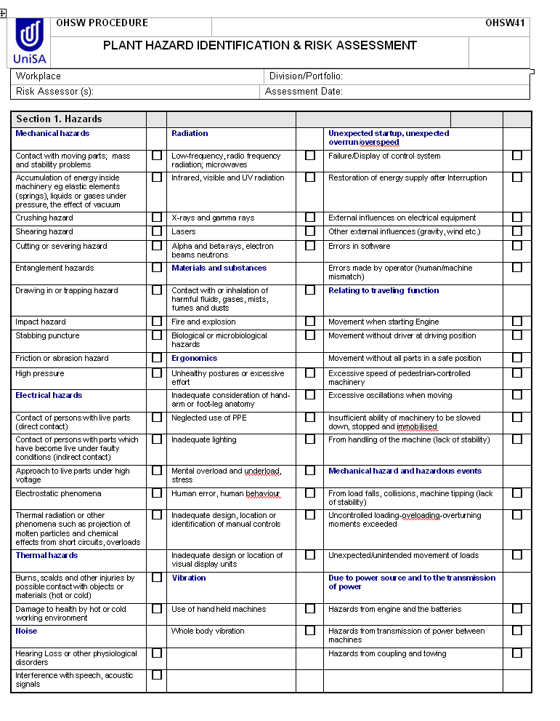

Exercise 9
- Create a hazard identification form that could be utilised within your workplace.

- Use this form to undertake a hazard identification process on one area within your workplace.

- Discuss the reporting processes that are undertaken once hazard identification steps have been completed within your workplace.

Risk Assessment
Once a hazard has been identified, its influence on the workplace needs to be assessed by the WHS committee. In this process, the committee is responsible for identifying the chance (risk) that the hazard can cause an injury. Risk assessment also involves classification of the risk according to the type of injury that may result whether it be death, permanent disability, injury or illness and whether time off work or first aid treatment that may be necessary.

This is often referred to as risk analysis and leads to a classification of the particular risk as:
- very likely
- likely
- unlikely
- very unlikely

For example, a piece of torn carpet under a desk could be considered a hazard but poses little risk, whereas a piece of torn carpet in the middle of a doorway is the same hazard but now poses significant risk. When conducting a risk assessment, each hazard needs to be individually addressed with common criteria including:
- Who is exposed to the risk?
- How often are people near the hazard or exposed to the hazard?
- Has this hazard already caused any problems?
- How easily could someone be hurt?
- Are there any WHS legislative influences that may affect your response to the identified hazard?
- Which factors or specific aspects of the work are increasing the likelihood of injury or illness?

Note: It is important to remember at this point that just because an identified hazard does not seem to be high risk when analysed on paper, it does not mean that it is not important to team members within that work area. One of the major barriers to maintaining effective WHS processes is losing the input of staff members. This will happen quickly if they feel that their issues are not considered important no matter how small the risk.

The form on the following page is a real life example from the University of South Australia (www.unisa.edu.au). It could be utilised to classify the risk in terms of the danger of the risk compared to the probability of a member of the workplace being exposed to it.
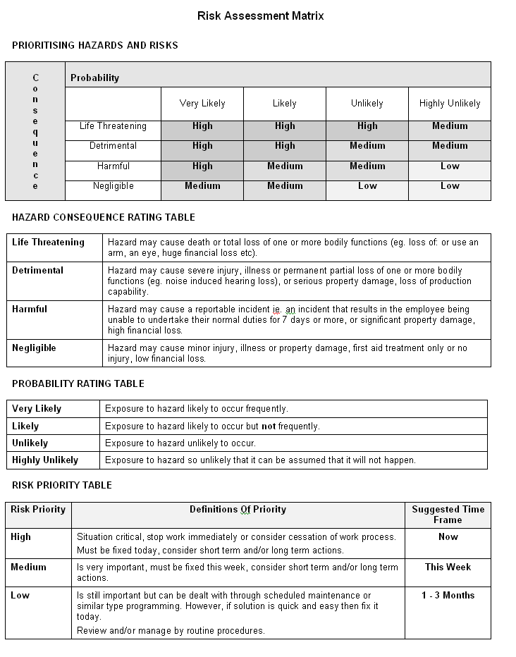

Exercise 10
- Create a risk analysis form that could be utilised within your workplace.

- Use this form to undertake a risk analysis process on a hazard identified in Exercise 9.

- Discuss your findings with your group/supervisor.

Risk Control
Once the hazard has been identified and its risk assessed, the final, and probably the most important, step is to control the risk. Controlling the risk is the process of removing or reducing the chance that the hazard can/could cause injury or illness to team members. There are usually a number of risk control methods that can be undertaken including:
Eliminate:
The hazard is completely removed from the work site. This may involve removing the hazardous equipment or substance or changing a work practice so that the hazard is no longer evident.
Substitute:
This process is common when a process still has to be completed but only a certain part is hazardous. The substitution may involve changing to a less corrosive cleaner or substituting dangerous equipment for a smaller or lighter model.
Upgrade or repair:
The faulty equipment is either repaired or upgraded. Upgrading usually entails a physical or engineering change to the equipment so that it functions in a different and less dangerous manner.
Isolate:
If the hazard is located within the workplace but not directly required for the completion of daily tasks (such as a loud air-conditioning unit), there may be the chance it can be isolated. This may involve moving it to an unused part of the workplace or enclosing it with soundproofing materials. Leaky pipes that pose slipping hazards etc. may also be isolated until they can be repaired.
Administrative Change:
If the hazard cannot be removed, isolated or repaired, it may be handled by an administrative change. Administrative changes include training, changes to task requirements or workplace routines or even movements. A painted walkway on a factory floor is a common example of an administrative change. Workers are required to follow the walkway at all times as to avoid hazards such as forklifts, electrical terminals or conveyer belts.
Identification:
Identification quite simply is the implementation of safety signs and symbols. Signage is used to alert prevent accidents, display the location of hazards, point out where emergency equipment is kept and identify the types of safety equipment (PPE) that should be worn.
PPE:
The introduction of PPE is a common resolution method when a hazard is identified. Most commonly implemented in conjunction with an administrative change, PPE is sourced and implemented into the processes undertaken to complete daily tasks. An example would be to introduce hair nets to workers on a factory floor where there is the risk of hair being caught in a conveyer belt etc.
The form below is a real life example from the University of South Australia (www.unisa.edu.au). It could be utilised to outline the risk management steps to be implemented after the analysis process has been completed.

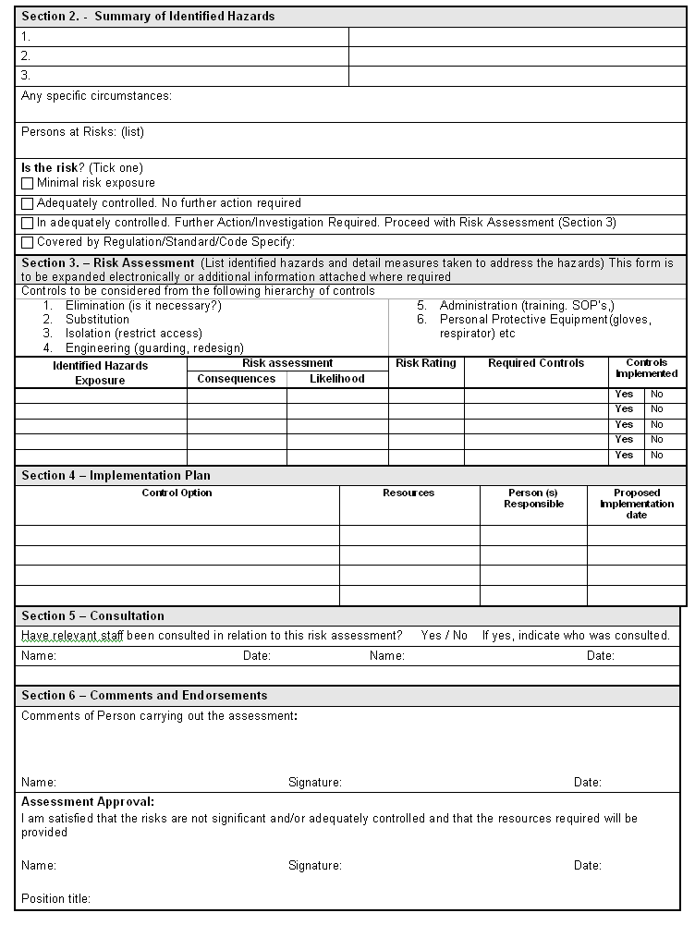

Exercise 11
- Create a risk management form that could be utilised within your workplace.

- Use this form to outline a hazard resolution process for the risk outlined and analysed in Exercises 9 and 10.

- Discuss your results with your group/supervisor.

Near Miss
A near miss is quite simply when an accident almost happens and is quite often overlooked as part of the WHS management procedures of the workplace. In cases where someone is almost hurt or an accident is narrowly avoided, most people tend to go with the old adage “no harm, no foul”. In actual fact, like a complaint in customer service, a near miss can be considered an opportunity to analyse and manage a risk before somebody does get hurt.

For example, a person in a factory plant may have narrowly avoided being hit by a large item on a production line. Once reported, the WHS committee then has the opportunity to analyse the hazard and mitigate its risk by:
- Undertaking an administration change to ensure that team members not working on that particular line are made to walk around it, not by it.
- Placing signage near the line to advise people that there may be large objects on the belt.
- Implementing a process where all persons are to wear hard hats whilst within the factory area.

The form on the following page is a real life example of a near miss form from the University of Ballarat (www.ballarat.edu.au ).

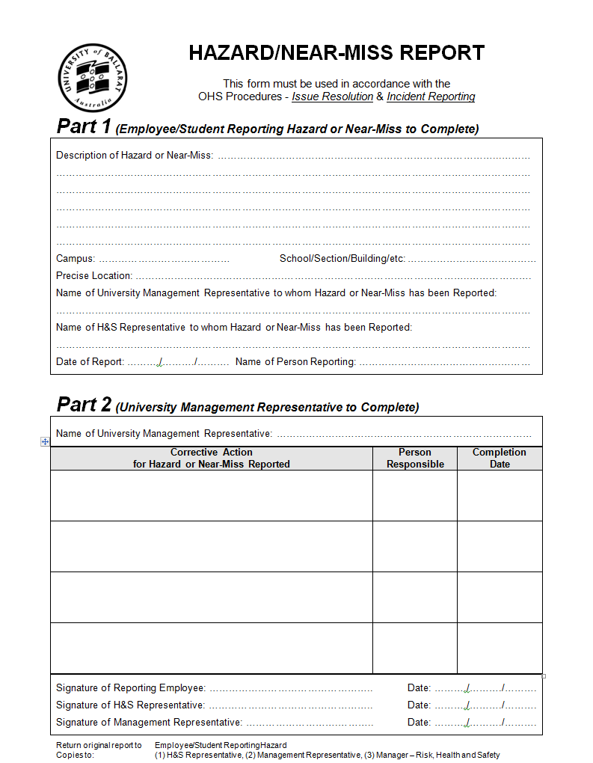

Exercise 12
- Create a near miss form that could be utilised within your workplace.

- Discuss any near misses that have occurred in your workplace and whether they have been effectively reported and actioned upon.

- Discuss any changes that may have been made as a result of a near miss.

Fire and Evacuation
Part of the ongoing duty of care requirements of the WHS committee is to ensure that fire and evacuation procedures are up to date. This not only involves being prepared for a fire, but ensuring that all members of the workplace are familiar with the evacuation procedures as well.

The Building Fire Safety Regulation 2008 stipulates the requirements for the ongoing fire management processes for a work site. In short, buildings that hold over 30 people are required to appoint and train a Fire Safety Adviser who is responsible for:
- Provision and maintenance of fire extinguishers.
- Development of fire and evacuation plan.
- Posting of evacuation signs.
- Fire safety and alert system installation and maintenance.
- Undertaking fire training processes for workplace staff members.

Fire Extinguishers
One major aspect of fire safety is to ensure that effective and up to date fire extinguishers are available for use in the workplace. There are a number of different extinguisher types for different types of fire. The matrix below outlines the types of extinguishers that may be available within the workplace:
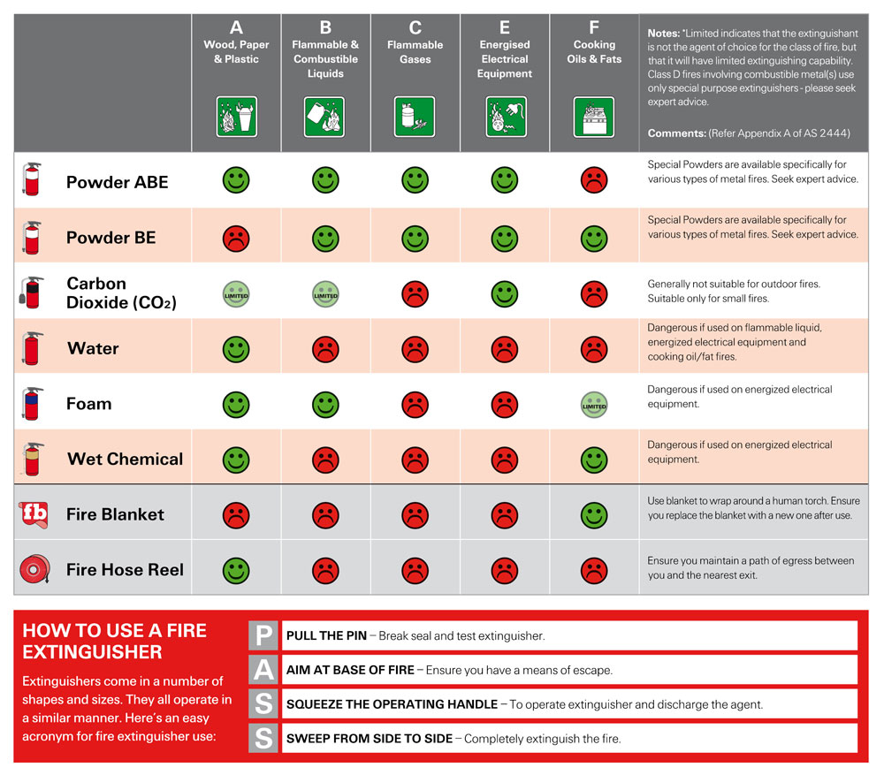
Source: www.exelgard.com.au

The inspection, test and maintenance regime for fire extinguishers is specified in the Australia Standard AS 1851 Maintenance of Fire Protection Systems and Equipment. As part of your workplace’s ongoing fire compliance requirements, fire extinguishers should be inspected and tagged every six months.

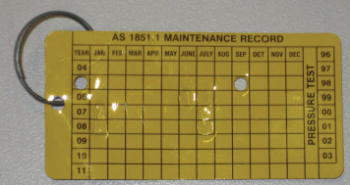
Fire Safety Tag
Source: www.fpaa.com.au

Note: Fire extinguishers are in place for use by trained personnel for small fires only. Should at any stage you feel that you are unable to use the extinguisher, not sure if you have the correct extinguisher or feel that the fire is too large, you should evacuate the area immediately and await the arrival of professional fire safety officers.

Evacuation Plans
An evacuation plan is arguably the most important aspect of a fire management process. This plan must be developed and published so that all staff members know exactly how to safely exit from anywhere within the building should a fire or other emergency arise. This process involves:
- Creating an evacuation map for every part of the building.
- Posting the evacuation maps in the applicable locations.
- Undertaking evacuation drills so that staff members are familiar with the routes to be taken.

The fire evacuation map should contain:
- Complete floor plan with current location highlighted.
- Clear display of evacuation path to be followed.
- Locations of ALL fire exits (in case one is blocked).
- Locations of PPE such as fire extinguishers, fire blankets or hoses.

An example evacuation map is as follows:

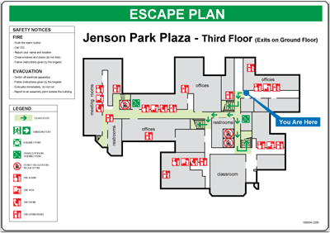
Source: www.clarionsafety.com

Evacuation Signs

As with WHS signage, fire evacuation signs and apparatus should be clearly signed so that staff members can easily locate them if required even during an emergency situation. Some of the required fire signage is as below:
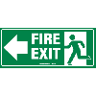
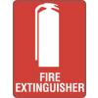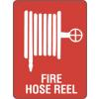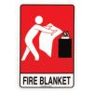

Source: www.bronsonsafety.com.au

Alert Systems

Part of the legislative processes for fire safety standards is the installation and management of Fire Alert Systems. These systems provide the audible warning tones that are heard whenever there is a fire or other emergency that requires the building to be evacuated. Most alert systems have two distinct signals that specify the behaviours required at different points of the emergency.

Alert Signal: The alert signal is usually a series of beeps that warn staff that there is an emergency and that they may need to evacuate. At this signal, staff are required to stand and head to the designated assembly point for further instructions from the fire safety officer or designated floor warden.

Evacuation Signal: The evacuation signal is a siren like sound that will indicate that the building is to be evacuated along the routes set out on the evacuation map. All staff are then led to a pre-determined evacuation point where a role is taken to ensure that all have evacuated safely.

When evacuating a building, it is critical that you follow all instructions given to you by the fire safety officer, floor warden, fire brigade or police at all times. Do not use lifts unless directed and exit the building as soon as it is safe to do so.

Fire Training

In most workplaces, staff members are required to undergo initial and then refresher fire training at least annually. This training is important as it keeps the work team up to date with information such as advances in technology in terms of fire extinguishers, alert signals etc. as well as their locations.

On top of this, fire and emergency drills are carried out roughly every six months where alert signals are activated and staff evacuated as per a real emergency. This is to keep them up to date with evacuation sounds and procedures as well as assist in the identification of any obstacles that may arise during an evacuation. These obstacles can then be removed or managed so that they are no longer a threat in the case of a real evacuation.

All fire evacuation training and drills should be observed and analysed by a designated member of the WHS committee. These results should be recorded and reported as part of an ongoing fire management process.

Exercise 13
- Create an evacuation map that could be utilised within your workplace.

- Use the map created above to check the maintenance tags for each fire extinguisher within your workplace. Discuss with appropriate personnel should any require attention.

- Discuss the fire training procedures undertaken within your workplace. Are there any improvements that could be made?

Accident Reporting
When an accident or incident occurs within the workplace, it is imperative that an accident/incident report is completed and presented to the WHS committee, representative or a supervisor, team leader or manager. This should happen as soon after the accident or incident as possible. In the State of Queensland and most other states, workplaces are required by law to report incidents in the workplace where there is:
- Serious bodily injury
- Work caused illness
- Work caused psychological illness (Work caused illness)
- Dangerous event
- Dangerous electrical event
- Serious electrical incident

An example of an accident report form is as follows:

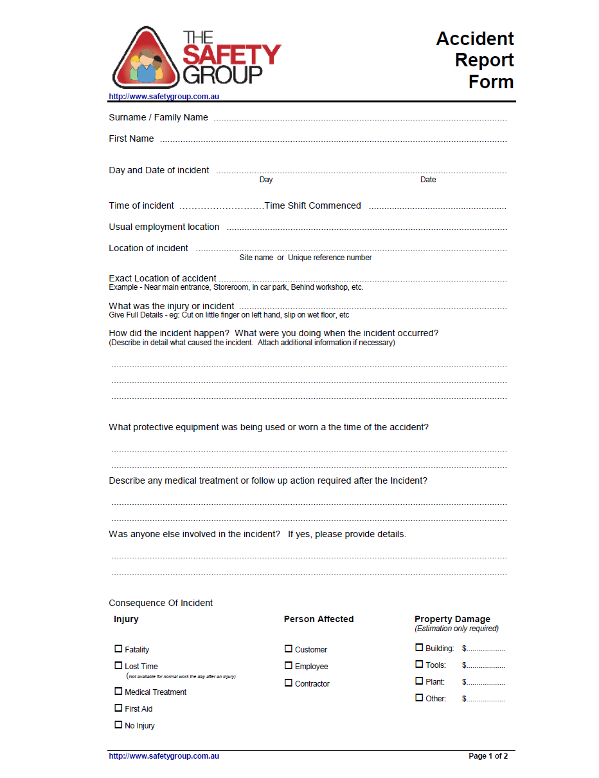

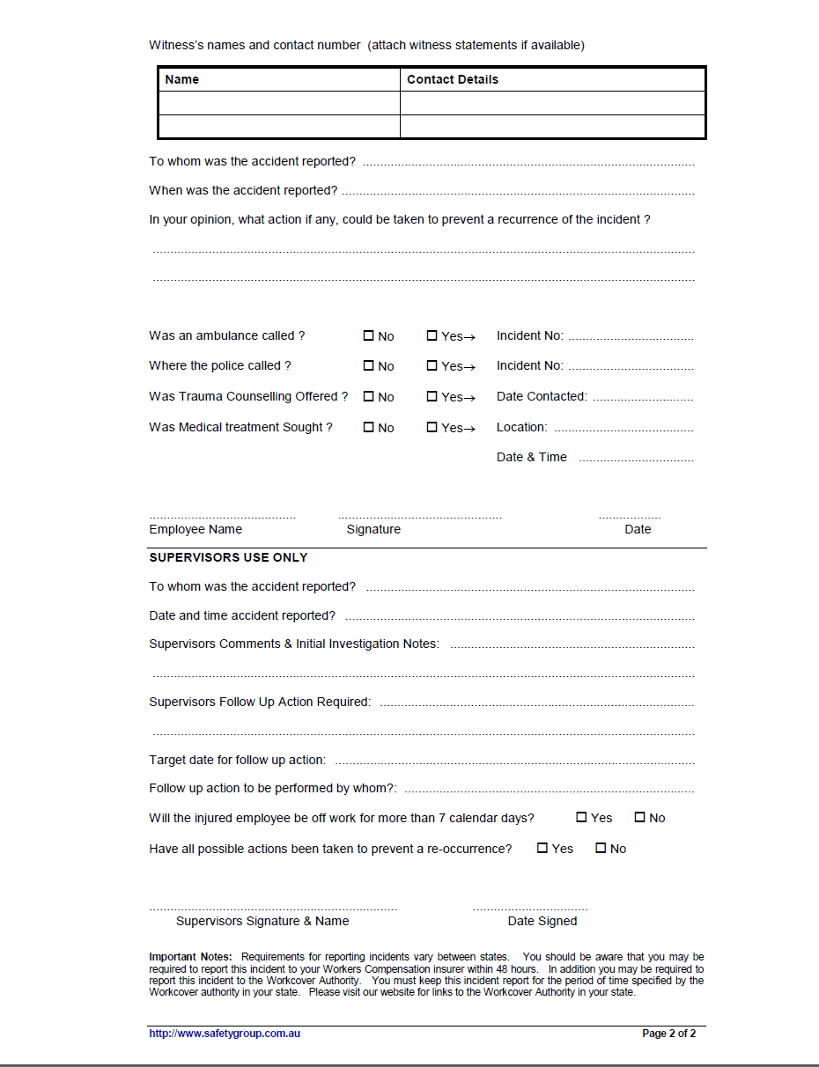

Source: www.safetygroup.com.au

Injury/Incident Register
Whenever an accident or incident is reported within the workplace, all details of these occurrences are recorded in the Injury/Incident Register. This is a critical step in the WHS process of any workplace as it allows for:
- The WHS committee to keep track of accidents and incidents in the workplace.
- Research into accidents and incidents that have occurred as part of the hazard/risk identification process.
- Ongoing decisions in regards to workplace safety to be made based upon these reports.

An example of an injury/incident register is as follows:

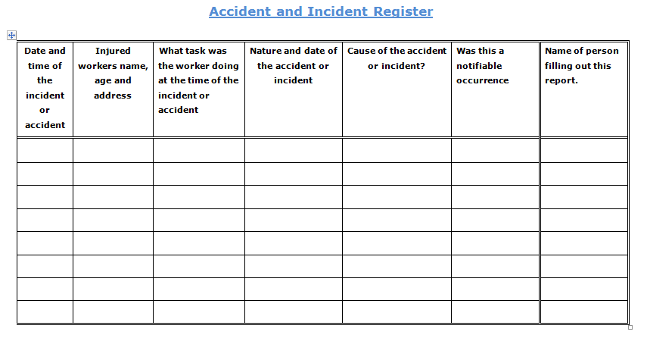

Exercise 14
- Create an accident/incident reporting form that could be utilised within your workplace.

- Refer back to the fire evacuation map created in the previous exercise and add the location of any first aid kits etc.

- Discuss the processes undertaken within your workplace once an accident has occurred and the post analysis steps have been undertaken.

