**Implement and Monitor Environmentally Sustainable Work Practices**

BSBSUS401

**Computer Training Manual**

**for ICA11 Information, Digital Media and Technology**

Copyright Information

*PO Box 15062*

*City East, Brisbane QLD 4002*

***Ph 1300 309 744***

*Fax (07) 3229 1254*

*manuals@datadiscovery.com.au*

*www.datadiscovery.com.au*



*DDICT302*

**Author: Paul Watson**

**© Data Discovery 2012**

**Version 1: February 2012**

This manual is copyright. No part of this manual may be reproduced or transmitted in any form or by any means, electronic or mechanical, including photocopying, recording, or by any information storage and retrieval system, without the written permission of Data Discovery.

**You have three options when purchasing these manuals:**

1. Purchase a single copy for each user, a class set or a copy for each computer

2. Purchase a paper Site Licence for making unlimited copies of this manual

3. Purchase a Copyright licence to alter the contents of the manual

*Class sets of these training manuals are available.   
Do not purchase one manual and make your own copies. You have not been given permission to copy even a part of this manual.*

The software used in the production of this manual was Microsoft Word 2010, Microsoft Windows 7 and SnagIt 10.

Microsoft®, Microsoft® Windows™, Microsoft® Word for Windows™, Microsoft® Excel for Windows™, Microsoft® PowerPoint™, Microsoft® Access for Windows™, Microsoft® Publisher™, Microsoft® Outlook are registered trademarks of Microsoft Corporation.

All information is correct to the best of the author’s knowledge. The author has made every attempt to ensure accuracy but cannot be held responsible for any loss or damage arising from any information contained or implied in this publication.

**Data Discovery**  
**PO Box 15062**

**City East, Brisbane Q 4002**

**Ph: 1300 309 744  
Fax: (07) 3229 1254  
email:** [**manuals@datadiscovery.com.au**](mailto:manuals@datadiscovery.com.au)

**website: www.datadiscovery.com.au**

Table of Contents

Introduction i

Elements of Competency ii

Employability Skills Summary v

Table of Contents vii

Sustainability 1

Our Environmental Footprint 1

Environmental Legislations 4

Business Sustainability 7

Efficiency 9

Compliance 13

Measuring Compliance 13

Measuring Workplace Efficiency 15

Sustainability Barriers 20

Compliance Reporting 22

Sustainability Practice 24

Sustainability Representatives 24

Sustainability Meetings 28

Consultation Processes 32

Sustainability Policies 38

Improvement Processes 41

Improvement Identification 41

Goals and Targets 45

Implementing Improvements 47

Managing Information 51

Continuous Improvement 57

Monitoring Environmental Behaviour 57

Sustainability

Environmental impacts and business sustainability have become more and more prevalent in mainstream media and political discussion over the last decade. So much so that individuals and businesses alike are investing vast amounts of time and money into the management and preservation of our natural resources.

So, what is sustainability?

Sustainability is the process of meeting the resource needs of the present without compromising the needs of future generations. To this end, business sustainability is the term given to the strategies surrounding meeting the resource and staffing needs of the business without again jeopardising the needs of the future.

Source: [www.derm.qld.gov.au](http://www.derm.qld.gov.au)

Our Environmental Footprint

Every person, everywhere in the world performs functions daily that require resources from, and return waste to, the environment. The impact that we leave when we perform these tasks is called our Environmental Footprint. If you think about the basic tasks that you perform every morning:

1. Get out of bed – Did you turn on a light?
2. Have a shower – Was your water nice and hot?
3. Breakfast – Milk cold? Coffee hot? Maybe you even listened to the news on the TV or Radio.

Now, we know that you did not go out and chop down a tree to heat the water, nor are we asking you to turn off your refrigerator or drink cold coffee. We are simply attempting to look at ways that we can still enjoy these luxuries without exhausting precious environmental resources for future generations.

Exercise 1

* Discuss your knowledge of the terms Sustainability and Environmental Footprint.

|  |
| --- |
|  |
|  |
|  |
|  |
|  |
|  |
|  |

* What sustainability processes are you aware of that are undertaken within your workplace?

|  |
| --- |
|  |
|  |
|  |
|  |
|  |
|  |
|  |

* Discuss any current events that are relevant to sustainability and the environment and how they may affect you/your workplace.

|  |
| --- |
|  |
|  |
|  |
|  |
|  |
|  |
|  |

Real Life Impacts: Carbon Tax

At the time of writing, great debate is underway in Australian politics, business and households in regards to the carbon tax. The current Australian Government plans to introduce a tax on the carbon emissions of companies that emit large amounts of greenhouse gasses into the environment. These companies will be charged a tax on every tonne of carbon that they release into the environment. Carbon measurement is explained by the Queensland Department of the Environment and Resource Management ([www.derm.qld.gov.au](http://www.derm.qld.gov.au)) as follows:

Abolished 1/7/2014

*“The term greenhouse gas actually refers to a combination of many different gases, of which carbon dioxide is the most common. The extent to which each of the gases contributes to the greenhouse effect and thus climate change is referred to as its global warming potential (GWP).*

*Carbon dioxide (CO2) has a GWP of 1; and the GWP of other gases is measured relative to the GWP of carbon dioxide. For example, methane (CH4) has a GWP of 21.*

*In greenhouse terms a tonne of methane is referred to as 21 tonnes of CO2 equivalent (CO2-e for short). The term ‘carbon emissions’ is often used to refer to emissions of carbon dioxide.”*

The point in question is that the major “polluters” in the proposed tax scheme are often the companies that produce our energy needs. The argument for the tax is that it will force these companies to find cleaner, more environmentally friendly ways to produce energy or manufacture their goods. The argument against is that the tax will not reduce our environmental footprint but simply drive up the cost of most of the commodities that we require.

We are not here to settle that argument, simply to highlight the impact that environmental sustainability has on all walks of life within this country.

Environmental Legislations

Environmental Legislation in Australia is relatively new and constantly being updated as new information and research comes to light. The current overriding environmental legislation is the *Environment Protection and Biodiversity Conservation (EPBC) Act 1999* which is managed in conjunction with numerous national and state environmental, historical and cultural acts*.*

It is managed by the Commonwealth Department of Sustainability, Environment, Water, Population and Communities.

[www.environment.gov.au](http://www.environment.gov.au)

A copy of the legislation can be found at:

[www.environment.gov.au/epbc/about/index.html](http://www.environment.gov.au/epbc/about/index.html)

There are also a number of environmental laws that cover specific areas including (and a very small representation):

* Environment Protection (Sea Dumping) Act 1981
* National Environment Protection Council Act 1994
* Hazardous Waste (Regulation of Exports and Imports) Act 1989
* National Greenhouse and Energy Reporting Act 2007

Source: [www.weblaw.edu.au](http://www.weblaw.edu.au)

Impacts of Business Sustainability

The EPBC Act influences the sustainability requirements of Australian businesses through the implementation of the following principles:

1. Decision‑making processes should effectively integrate both long‑term and short‑term economic, environmental, social and equitable considerations.
2. If there are threats of serious or irreversible environmental damage, lack of full scientific certainty should not be used as a reason for postponing measures to prevent environmental degradation.
3. The principle of inter‑generational equity—that the present generation should ensure that the health, diversity and productivity of the environment is maintained or enhanced for the benefit of future generations.
4. The conservation of biological diversity and ecological integrity should be a fundamental consideration in decision‑making.
5. Improved valuation, pricing and incentive mechanisms should be promoted.

Sourced directly from: [www.comlaw.gov.au/Details/C2011C00751](http://www.comlaw.gov.au/Details/C2011C00751)

Failure to comply with this Act is dealt with under Chapter 2 of the *Australian Criminal Code*.

Further information and legislative requirements can also be found in:

* Corporations Act, Section 169 (Director’s Statement on environment)
* Trade Practices Act Section 52 – Green marketing
* Australian Standard Greenhouse Gases Parts 1 and 3
* Department of Climate Change - National Greenhouse Reporting Act National Environment Protection Council guidelines
* Greenhouse Gas Protocol
* Global Reporting Initiative (GRI)

Breaches

When dealing with environmental sustainability and efficiency issues, we can use two categories to categorise real and potential breaches. These are:

**Actual Breach** – the breach has occurred and must be reported to relevant workplace personnel* (sustainability or workplace managers, sustainability committees, team leaders etc.) for action. This person should then:

* Analyse the breach against compliance requirements to determine seriousness.
* Assess the risk level to measure possible implications of the breach.
* Instigate rectification processes.

**Potential Breach** – A potential breach, as with a safety near miss is where a breach has not actually occurred, but an issue has been identified that could result in a breach of environmental sustainability and efficiency requirements. As with an actual breach, a potential breach should be reported to relevant workplace personnel for analysis, risk assessment and rectification processes.

*\*We will discuss reporting procedures later in this manual.*

The following is an excerpt from the New South Wales Office of Environment and Heritage outlining some potential penalties for breaches of environmental legislations within that State.

*The most serious offences (Tier 1 offences) are wilful breaches of the law that harm or are likely to harm the environment. These carry penalties of up to $5 million for a company or $1 million for an individual and/or seven years imprisonment.*

*Where breaches are negligent, the penalties for the most serious offences are up to $2 million for a company or $500,000 for an individual and/or four years imprisonment.*

*Most other offences (Tier 2 offences) carry penalties of up to $1 million (plus a daily penalty of up to $120,000 for continuing offences) for companies or $250,000 (plus a daily penalty of up to $60,000 for continuing offences) for individuals.*

*Less serious breaches can result in an 'on-the-spot' fine (penalty notice) with a penalty of $750 for individuals and $1500 for companies.*

*Penalty notices (Penalty Infringement Notices or PINs), operate very similarly to a speeding ticket and are administered by the State Debt Recovery Office, which is the fines division of the Office of State Revenue.*

Sourced directly from [www.environment.nsw.gov.au](http://www.environment.nsw.gov.au)

Exercise 2

* Undertake some research into the above acts and legislations and identify three areas of information that may affect your workplace.

|  |
| --- |
|  |
|  |
|  |
|  |
|  |
|  |

|  |
| --- |
|  |
|  |
|  |
|  |
|  |
|  |
|  |
|  |

* Discuss your finding with your group/supervisor including the processes you would follow should a compliance breach be identified.

|  |
| --- |
|  |
|  |
|  |
|  |
|  |
|  |
|  |
|  |
|  |
|  |
|  |
|  |

Business Sustainability

When we talk about business sustainability, there is an approach that is commonly undertaken which is outlined in the first section of the EPBC Act outlined earlier in this manual.

*“Decision‑making processes should effectively integrate both long‑term and short‑term economic, environmental, social and equitable considerations.”*

This effect of economic, environmental, social and equitable considerations is quite often described as a triple bottom line principle being:

* Profit
* People
* Planet

The idea behind triple bottom line reporting is that for a company to be considered environmentally successful, it not only needs to report on traditional financial results but also cover areas of their management of social and ecological issues.

Profit

It goes without saying that all businesses are run to make a profit. When the term profit is used in this context however, it is aimed at ensuring that the business does not operate on a “profit at any cost” process. A sustainable profit is made by ensuring that manufacturing processes are undertaken as cleanly and efficiently as possible. Some of the steps that can be taken to make a sustainable profit include:

* Using ‘Green’ or recyclable packaging and consumables.
* Offering concentrated products that use smaller containers and last longer.
* Finding alternative ingredients and products that are safer on the environment.
* Only dealing with suppliers who utilise the same principles.
* Use environmental waste disposal programs.

The environmental dilemma for many companies is that these steps are not always the cheapest. For example, the removal of some chemicals from manufacturing tasks may make the whole process take longer or companies that use recyclable packaging only may make supply costs more expensive. Rising business costs will always cause ethical dilemmas for business owners. It is critical however that these costs are analysed carefully as in many cases, what can cost more in the short term will actually save the company money later on. We will discuss some of these examples later in this manual.

People

When we discuss the terms sustainability and efficiency within the workplace, the word ‘resources’ is often used. Most commonly when we hear this term, we think of natural resources such as water, fuel and gas. Good managers, environmentally minded or not, will tell you that the most important resource in any business is its workforce.

In the next section of this manual, we will discuss the effects of efficiency on business sustainability. One of the biggest threats to business efficiency (and profit) is high staff turnover. Adding new staff members to a business cost large sums of money in training, lost productivity and wastage. Staff retention measures that can be undertaken include:

* Fair pay schemes.
* Intra-company services (health plans, social clubs etc.)
* Community projects, sponsorships and donations.
* Flexible working conditions – Job share etc.
* Ability to Telecommute / web conference.

Again, some of these undertakings can command greater impacts on the overall profit line of the company. However, these costs often pale into insignificance when compared to the costs of constantly acquiring and training new staff.

Planet

The planet principle is a little different to the previous two as it is often the hardest to measure (one major argument of the carbon tax scheme). This tier simply outlines how a business impacts the planet. Many of the processes undertaken under the Profit tier will affect this area as well as efficiency programs. Planet measurements are however often measured in behaviours affecting the planet that may be outside of the actual business tasks including:

* Carbon trading.
* Reduction of toxic materials in manufacturing processes.
* Use of ‘fair trade’ products.
* Buy back and recycling programs for products and packaging.

Efficiency

So far in this manual, we have briefly discussed some examples of our daily use of environmental resources*.* We have also established that sustainability is about using the resources we need now whilst ensuring that they are available for future generations as well. Obviously the easiest way to save precious resources for the future is to not use them at all. However, as this is not a realistic or viable option, we need to manage how we do use our resources.

One major behaviour that we can implement is to ensure that we use our resources efficiently and effectively. In simple terms, if we are using our resources efficiently, there is a good chance that we can we are not only purchasing just what we need, but using them in a manner that reduces wastage and increases output as much as possible.

Let’s now have a look at one of our own daily processes in terms of environmental usage and efficiency (after all, efficiency is a part of maintaining sustainability and the two do go hand in hand). When we make a cup of coffee, we use a number of resources including water, coffee, milk, sugar and electricity.

The question is how can be better use the resources at our disposal when making our daily cup of coffee in an attempt to reduce our environmental footprint? To do this, let’s break down the task:

1. Fill the jug with water, plug it in to an electrical socket and turn it on.
2. Take a cup from the cupboard.
3. Add coffee and sugar from the pantry and milk from the fridge to the cup.
4. Add boiling water to the cup and stir…… delicious!!

Now, let us have a look at the questions that we could ask (just a few or we could be here all day!) and see where we can not only be more environmentally friendly, but work more efficiently as well.

|  |  |
| --- | --- |
| Can we be more efficient when boiling our water? | Can you boil the jug for two or more people at once instead of boiling the jug twice?  Does the jug have an auto shut off for when it has boiled? |
| Are the ingredients environmentally friendly?  Are we purchasing efficiently? | Can you purchase staples in recyclable packaging?  Do the ingredients come from “fair trade” countries?  Can we buy a bulk pack meaning we are not purchasing as many smaller packages?  Do the manufacturers of the products follow environmentally sustainable principles? |
| Is the cup reusable? | Can you replace a plastic or foam cup with a china or stainless steel mug? |
| Does your pantry have a light? | Can you store commonly used staples such as coffee on a shelf so the pantry light is not being constantly turned on and off? |
| How do you clean your cup? | Do you use chemical free detergents?  Do you ensure that the dishwasher is full before turning it on? |
|  |  |

Wow, all that just for a cup of coffee! Makes you think though doesn’t it!

Exercise 3

* Discuss your workplace’s sustainability considerations in the following areas.

|  |
| --- |
| Profit |
| People |
| Planet |

* Discuss with your group/supervisor any improvements that could be made (don’t forget to think about the cost and realism of these changes).

|  |
| --- |
| Profit |
| People |
| Planet |

* Undertake some research and discuss what is meant by a "fair trade" country. How do these countries assist in the process of sustainability?

|  |
| --- |
|  |
|  |
|  |
|  |
|  |
|  |
|  |
|  |

* Create a form that could be utilised within your workplace to analyse the resources used within a task.

|  |
| --- |
|  |
|  |
|  |
|  |
|  |
|  |
|  |
|  |
|  |
|  |
|  |
|  |
|  |
|  |
|  |
|  |
|  |
|  |

Compliance

Even though many of the legislations listed (and many more that are not) in the previous pages of this manual are relatively new to most workplaces, workplace representatives are still required to research and identify the behaviours and processes required to remain compliant with them. In most cases, these compliance requirements are simply to ensure that workplace tasks are run as efficiently as possible in accordance with sustainability policies and principles.

In extreme cases however, heavy penalties can be imposed upon companies and/or individuals who breach sustainability and/or environmental regulations in areas such as pollution, excess damage to nature/bushland or ecological issues (exceeding fishing limits etc.).

Measuring Compliance

Measuring and reporting sustainability and environmental compliance works in a similar fashion to the hazard and risk identification procedures of Occupational Health and Safety. As with OH&S, just because an environmental hazard is known, it does not mean that it is being effectively managed. To ensure that this is the case, an environmental hazard and compliance identification process is undertaken. Environmental hazard identification procedures or audits should consist of a number of steps including:

|  |  |
| --- | --- |
| **Observation:** | A job or task is observed from start to finish and areas of potential environmental and/or efficiency risks are identified and noted. |
| **Records:** | Sustainability policies, efficiency change reports and purchase reports/records are checked to see where previous efficiency and sustainability hazards have been identified. |
| **Meetings:** | Staff members are interviewed in a one on one or meeting based environment for input in regards to hazards that they have observed or identified within their own work areas. |
| **Inspection:** | An inspection of an area is undertaken to identify known and potential environmental hazards and issues. |

*Each of the areas above will be discussed in more detail in the pages of this manual.*

The example on the next page is an excerpt from a sustainability checklist that could be utilised to check workplace compliance.

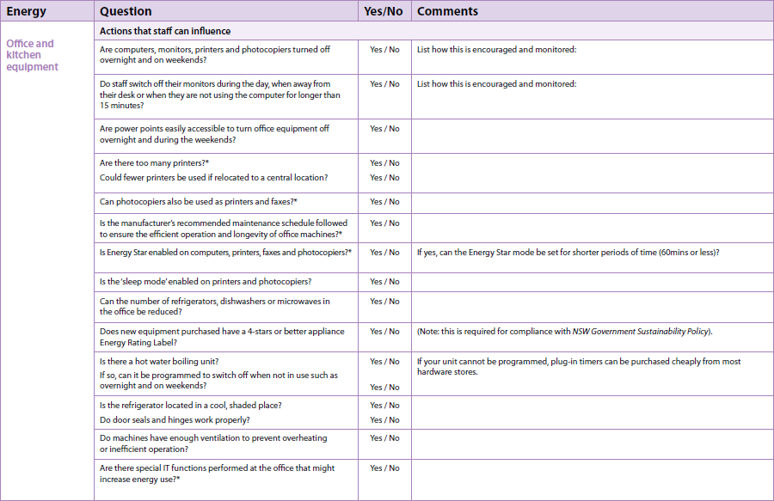

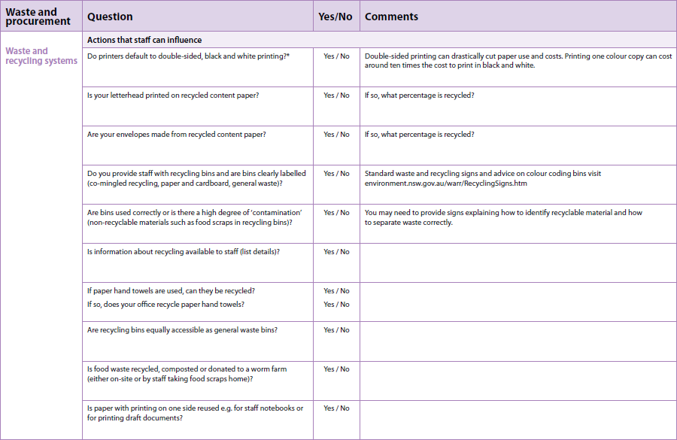

Source: [www.environment.nsw.gov.au](http://www.environment.nsw.gov.au)

Measuring Workplace Efficiency

As we discovered earlier with our environmentally friendly cup of coffee, we were able to identify sustainable impacts and change requirements by breaking the task down into simple steps. In order to measure the efficiency of our workplace tasks, we can break down each task as applicable and check the following:

* Are we using the best resources?
* Are we managing their use effectively?
* Are we purchasing the correct amount or the correct size?
* Are we recycling where possible?

Checking Resources

As you break down each workplace task, you will quickly identify the resources that are required to complete these tasks. For example, you use:

* Paper and toner/ink cartridges on a printer.
* Fuel, oil and water for company cars.
* Chemicals in bathrooms, factories or for cleaning.
* Time that equipment is sitting idle.

**Did you know?**

In 'developed' countries, idle equipment sitting in standby mode can represent up to 12% of household electricity consumption. In Australia, standby power could be costing consumers around $500 million every year resulting in greenhouse gas emissions of more than 5 megatonnes (CO2 equivalent) annually. Worldwide, standby power is estimated to account for as much as 1% of global greenhouse emissions.

A computer and monitor left on for a year generate the same amount of CO2 as a car travelling from Sydney to Perth.

* Printers spend approximately 95% of their time sitting idle.
* Fax machines are often left on continuously, but their actual use time amounts to only about 1 hour per day.
* Screensavers do not reduce the power consumption of a computer monitor unless they actually turn the monitor off.
* Home electronics products currently use anywhere between 1 watt and 20 watts on standby, and can be in this mode for between 16 and 22 hours per day.
* More information about standby power is available on the Energy Rating web site at (and this information directly sourced from) [www.energyrating.gov.au/standby.html](http://www.energyrating.gov.au/standby.html)

Analysing Use

Once the resources in use have been identified, each one needs to then be fully analysed to ensure that it is not only being used efficiently, but is the most appropriate for the intended outcomes of the task. Below are some examples of how these checks can be carried out:

**Check Usage Records**

The first step in the resource analysis process is to establish current use in order to establish a baseline. A baseline provides us with two major measurements:

1. Gives us a clear picture of what we are using.
2. It can be used to measure improvement once any efficiency enhancements have be implemented.

**Note**: When measuring usage, you may need to check processes at different times of the day at peak and non-peak periods. Sometimes, resources are used less efficiently at non-peak times as more “one off” jobs tend to be performed at during these periods.

**Check Manufacturer Documentation**

Many manufacturers include energy and resource saving tips in their user manuals or on their websites. Some of the areas that can be researched into include:

* Power management settings for computer and electronic equipment.
* Listings of the resources or fuels that work best in, or are designed for their equipment.
* Outlines for the use of recycled resources.
* Suggestions for wastage or exhausted resource containers.

It is important to note, the some manufacturers also outline their restrictions on the use of recycled resources in their equipment. Some will even void equipment warranties if recycled items are used. This should always be checked before any new resources are sourced as part of the efficiency improvement process.

**Check with Suppliers**

Check supplier invoices to ensure that all purchase are made only when necessary and in the best manner. For example, are you making a lot of small purchases when you could be making one large one or could you be buying in bulk and throwing out unused stale product?

Changes to purchasing arrangements could not only save your company money, but also save the environment with reduced transport requirements.

**Check Processes**

In this step, we need to not only look at the resources that are in use, but how we use them. For example, you may have some staff members who spend part of their day out and about visiting customers in a company car. A simple check can be undertaken to see whether they are completing all of their visits in the same areas or in one trip compared to revisiting the same areas on subsequent days or making one trip then returning to the office only to go out again later in the day.

Staff Input

Another way to gain information of the sustainability and efficiency practices of a workplace is to implement staff input and feedback processes. As with OH&S management, members of the work team are often best placed to identify and report efficiency issues that they experience in their daily tasks.

Feedback from staff members can be gathered in a number of ways including:

|  |  |
| --- | --- |
| **Surveys or questionnaires** | Staff members are given a series of questions based upon their use of resources or management of tasks within the workplace. The advantage is that questions can be answered without team members having to necessarily be trained in sustainability practises.  They may however, be hesitant to answer correctly if they feel that they could be held accountable if they do not answer within their perceptions of correct sustainable behaviour. |
| **Team meetings** | Team meetings can be a good place to discuss and manage workplace efficiency and sustainability practices. The principles and requirements can be clearly explained and team members given the opportunity to identify areas of improvement. |

Exercise 4

* Create a form that could be utilised to identify and analyse environmental and efficiency hazards within your workplace.

|  |
| --- |
|  |
|  |
|  |
|  |
|  |
|  |
|  |
|  |
|  |
|  |
|  |
|  |

* Use this form to undertake a hazard identification process on one task within your workplace.

|  |
| --- |
|  |
|  |
|  |
|  |
|  |
|  |
|  |
|  |
|  |
|  |
|  |
|  |

* In Exercise 3, we create a form that can be used to breakdown a task within the workplace. Use this form to record the steps required to complete a task within your workplace and then identify some possible improvements to efficiency. Discuss your findings.

|  |
| --- |
|  |
|  |
|  |
|  |
|  |
|  |
|  |
|  |
|  |
|  |
|  |

* Discuss other methods that you could utilise to locate information in regards to potential compliance breaches or inefficiencies within your workplace.

|  |
| --- |
|  |
|  |
|  |
|  |
|  |
|  |
|  |
|  |
|  |
|  |
|  |

Sustainability Barriers

As part of the triple bottom line principles we discussed earlier was the dilemma that many companies face when deciding whether to increase spending on items such as recyclable packaging or low chemical cleaners. Some of the issues that arise in this area form part of another aspect that should always be examined when undertaking an audit of the current environmental statues of a workplace. This aspect is the identification of any barriers that may exist. These barriers can be caused by a number of influences and must be accounted for during any process involving the future recommendation of improvements. Sustainability barriers can be considered as any process, attitude or behaviour that directly causes a risk to sustainability practices within the workplace. These barriers can be caused by the sustainability representatives, management or workplace team members and can include:

* Low level of commitment to sustainability processes
* Cost – e.g. Purchasing the cheapest consumables regardless of performance
* Shortcuts taken due to workplace requirements
* Lack of training and supervision
* Lack of/poor consultation with employees
* Lack of understanding of expectations and needs
* Invalid signage
* Lack of care by employers and/or employees
* Staff disinterest

These issues must be considered in any compliance or recommendation reporting that is presented.

Exercise 5

* Discuss some of the sustainability barriers that may be evident within your workplace.

|  |
| --- |
|  |
|  |
|  |
|  |
|  |
|  |
|  |
|  |
|  |
|  |
|  |
|  |

* Are there any processes within the workplace that you are aware of to overcome these barriers?

|  |
| --- |
|  |
|  |
|  |
|  |
|  |
|  |
|  |
|  |
|  |
|  |
|  |
|  |

Compliance Reporting

Once the efficiency and compliance measurement processes have been completed, a report should then be created that includes:

* Environmental hazards and non-compliance issues identified
* Current usage
* Identified barriers supporting documentation
* Baseline information
* Relevant legislation
* Recommendations (not always included)

Such is the importance of workplace sustainability processes, many companies use efficiency analysis reporting outcomes in documentation such as annual reports, sustainability policies, training manuals and business plans. Due to this, it may be important to ensure that the results are clearly documented and stored within workplace guidelines.

Setting Benchmarks

The measurement of the current environmental and efficiency status of a workplace can be utilised as benchmark information that we can use to set the improvement targets and strategies that we will cover later within this manual. A clear, concise record needs to be included outlining the current sustainability and efficiency status of the workplace. It is important that this section is strictly reported “as is” when the initial investigation processes were commenced even if some improvements have already been made. If not, it may be difficult to measure improvements down the track.

The current usage report should also include areas where improvements are not required. This is because in some cases, improvements made in some areas can actually have adverse effects in others. This will also need to be measured.

Writing the Report

The purpose of a report is to present information to the reader as quickly, accurately and succinctly as possible. The report should be presented in a formal style which includes the introduction, body and conclusion in a way that presents the information in an unbiased manner rather than mounting an argument.

A well written report should also:

* Use headings and sub-headings
* Contain short, concise paragraphs and dot-points where applicable
* Utilise graphics (tables, graphs, illustrations) wherever applicable to illustrate points and present data (such as consumable usage statistics etc.).

To allow the reader to quickly read and comprehend the report, presentation and style are important:

* Use plenty of white space
* Ensure the separate parts of the report stand out clearly
* Number each page
* Use consistent and appropriate formatting
* Use formal language

Exercise 6

* Use the information gathered in the previous exercises of this manual to write a brief report outlining the current compliance status of your workplace. Discuss your report with your group/supervisor.

|  |
| --- |
|  |
|  |
|  |
|  |
|  |
|  |
|  |
|  |
|  |
|  |
|  |
|  |
|  |
|  |
|  |
|  |
|  |
|  |
|  |
|  |
|  |
|  |

Sustainability Practice

Many workplaces, as part of their efforts to manage ongoing sustainable and “environmentally friendly” behaviours, will implement a series of sustainability processes that can include:

* Identifying current workplace status (covered in earlier sections of this manual)
* Identifying applicable representatives
* Holding Environmental and sustainability meetings
* Consulting with staff in regards to sustainability and efficiency processes
* Disseminating relevant information
* Drafting Sustainability policy documents
* Recommending improvements

Sustainability Representatives

Unlike Occupational Health and Safety*,* there is generally not one overriding act or legislation that outlines workplace staffing requirements to deal with sustainability (see the *Environmental Legislations* section earlier in this manual). Obvious pollution and environmental destruction issues aside, environmental behaviours are basically left to the motivations and requirements of the workplace. Once a workplace decides to undertake these processes, a sustainability representative is often identified. They may then undertake some or all of the following:

* Form sustainability committees, deputies and workplace section representatives
* Organise and manage sustainability committee meetings
* Undertake applicable internal and external consultation processes
* Maintain and distribute sustainability information to the workplace
* Manage barriers

***Note****: In many cases, the sustainability and efficiency functions within the workplace are incorporated into, and managed by the OH&S committee.*

Sustainability Committees

As we have discussed, the sustainability representative may identify the need to establish a committee to deal with the environmental and efficiency requirements of the workplace. This will be more common in companies that produce large amounts of waste or other environmental risks as part of their daily activities (manufacturing etc.).

The main functions of a sustainability committee are to facilitate discussion and consultation with the employer, employees and if required, national environmental bodies.

The key roles of a sustainability committee are numerous and can include:

* Identification and appointment of workplace inspection officers
* Providing advice and recommendations in regards to rules and procedures relating to environmental sustainability and efficiency practices
* Making recommendations in regards to the establishment of sustainability programs including induction, refresher and task specific information and training programs
* Reporting on the current status of the workplace
* Management of ongoing audit requirements such as hazard inspections, risk analysis and workplace maintenance
* Undertaking measures to ensure that the workplace is compliant with the environmental legislations within their industry, state or territory
* Identifying and overcoming any issues or barriers hindering the implementation of identified sustainability processes

As part of their commitments, all members of the committee are normally required to undertake formal training to ensure that they are knowledgeable in all aspects relating to their industry and state. They are also required to ensure that they are kept abreast of any changes to environmental acts and legislations.

Forming the Committee

The sustainability committee is generally made up of elected employees working at the workplace. It can however, at the request of the employer, also contain an external representative such as:

* An industry expert
* An environmental or efficiency specialist
* A representative of the business owner

There is no legislated set number of employees that can comprise a sustainability committee.

Exercise 7

* Who is responsible for maintaining environmental, sustainability and efficiency standards and behaviours within your workplace?

|  |
| --- |
|  |
|  |
|  |
|  |
|  |
|  |
|  |

* Does your workplace maintain a working sustainability committee?

|  |
| --- |
|  |
|  |
|  |
|  |
|  |
|  |
|  |

* Discuss how this committee was formed.

|  |
| --- |
|  |
|  |
|  |
|  |
|  |
|  |
|  |

* What is the composition of this committee (who sits on it?).

|  |
| --- |
|  |
|  |
|  |
|  |
|  |
|  |
|  |
|  |
|  |
|  |
|  |
|  |

* Discuss the functions that are performed by your sustainability committee.

|  |
| --- |
|  |
|  |
|  |
|  |
|  |
|  |
|  |
|  |
|  |
|  |
|  |
|  |

Sustainability Meetings

As with most subjects, for sustainability meetings to be of value, they must be efficiently and effectively run. Some tips to running effective meetings include:

* Send formal invitations to all members
* Create and distribute an agenda before the meeting
* Locate and provide supporting documentation (normally distributed with the agenda)
* Assign a meeting chair
* Stick to timeframes
* Keep discussions on topic as much as possible
* Finish on time

One of the sustainability barriers we discussed earlier was a lack of management or committee input. Committee members will be more likely to attend and contribute should these meetings be run efficiently and not gain the perception of being a waste of time. Personalities must be managed to ensure that all members are able to speak, listen and pass opinions as required.

Team Member Responsibilities

Just because a meeting is managed as required, it does not necessarily mean that it will be able to meet its requirements. All members must, by accepting their nomination and position adhere to the responsibilities of their tenure as a part of the committee. These responsibilities include:

* Attend scheduled meetings - or send apologies or a proxy if available
* Ensure that they are familiar with the agenda and/or supporting documentation such as minutes from previous meetings
* Give each meeting their full attention
* Provide advice as required
* Ensure familiarity with subject matter relevant to their own work areas
* Distribute information as relevant to relevant work areas

The example on the next page is of a sample meeting agenda that could be utilised for a sustainability committee meeting.

Source: [www.safework.sa.gov.au](http://www.safework.sa.gov.au)

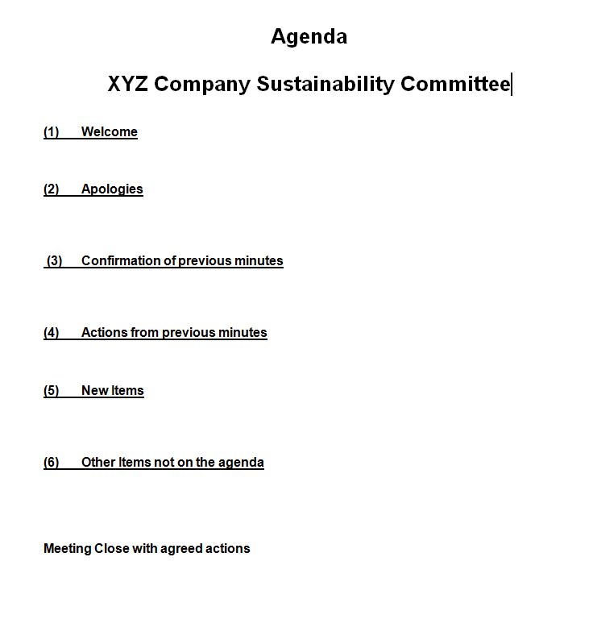

Exercise 8

* Discuss your experiences attending formal meetings. What processes were followed?

|  |
| --- |
|  |
|  |
|  |
|  |
|  |
|  |
|  |
|  |
|  |
|  |

* Discuss some of the items that should be included on the agenda for a sustainability committee meeting within your workplace.

|  |
| --- |
|  |
|  |
|  |
|  |
|  |
|  |
|  |
|  |
|  |
|  |
|  |
|  |
|  |

* Use the space below to create an agenda containing the information discussed in the previous question.

|  |
| --- |
|  |

Consultation Processes

In the *Compliance* section of this manual, we discussed a number of methods that can be utilised to check, identify and measure the compliance and efficiency status of the workplace. Some of these methods included:

* Observation
* Checking records
* Meetings
* Inspections
* Checking usage records and invoices
* Staff meetings and surveys

Each of these steps is the responsibility of the sustainability committee as part of their reporting requirements. In order to acquire this information, individual members of the committee are often assigned positions within the workplace. These tasks include:

|  |  |
| --- | --- |
| **Sustainability Officer** | Sustainability officers are members of the work team who perform the day to day tasks associated with sustainability and efficiency such as:   * Organising training * Holding workplace meetings * Investigating environmental incidents * Undertaking risk assessments * Maintaining sustainability documentation |
| **Workplace Trainer** | The workplace trainer (often the Sustainability Officer) is an officer utilised within the organisation to undertake any training required by staff members. The workplace trainer will generally need to be fully conversant with current legislations and the tasks carried out within the workplace. |
| **Inspection Officer** | The role of the Inspection officer is to undertake scheduled and random checks of the workplace in an effort to identify area of hazard or risk. They will also identify any maintenance issues (leaking of oil in equipment in need of repair etc.). |

|  |  |
| --- | --- |
| **Environmental Protection Inspectors** | Each state or territory governing body appoints inspectors to enforce environmental legislations. These inspectors can visit a workplace under appointment, after an accident or at random to:   * Undertake checks for adherence to legislations * Provide advice * Complete incident or breach reports   In some states, environmental Inspectors also have the power to issue warnings, fines or even instigate workplace shutdown procedures. |

This table highlights some of the consultation processes that can be undertake by various delegated members of the committee. The main purpose of these processes is to gather the information to allow the committee to make decisions and recommend improvements effectively.

Reporting Environmental Issues

At the end of the day, no person is more readily available to provide up to date information in regards to the safety of a particular area than the person who is working within it. The audit processes outlined so far in this manual have been explained from the point of utilising relevant tools to identify and gain an understanding of compliance issues. The second part is to establish processes that allow for members of the workplace to report issues proactively. Workplace staff should be kept up to date and informed on all environmental and efficiency aspects so that they are in a position to report any issues that they have identified. These issues are reported to the OH&S representative via:

* Workplace meetings
* Training sessions
* Reporting forms (observation checklists, audit forms etc.)

**Workplace Meetings**

The purpose of workplace meetings is twofold:

1. To disseminate information such as improved practices, environmental legislation updates or requirements, identified hazards or risks and future training courses etc. from the committee to the workforce.
2. To allow the workforce to raise or highlight issues that relate to their own work areas.
3. Maintain ongoing staff interest and support.

Workplace meetings are generally informal proceedings that allow staff members to mingle and discuss information as required. It is critical however, that information raised is reported to and acknowledged or acted upon by the committee. Failure to do so will compromise the process of gaining accurate information from the workplace at future meetings.

**Training Sessions**

Training sessions are most often carried out in areas (such as construction, manufacturing or mining) where legislated environmental risks such as pollution are evident. In these cases, staff members are required to attend mandatory training in regards to the environmental risks within their workplaces. Other companies hold training courses as a means of ensuring that all members of the work team are able to complete their requirements safely within workplace policies and procedures.

Training courses are usually more formal than workplace meetings and do not normally allow for the reporting of the current status of the workplace.

**Reporting Forms**

Reporting forms can be placed in common areas such as breakout rooms and meeting areas to allow team members to record suggestions, breaches and other issues to the committee. A delivery mechanism (such as a suggestion box) should be put in place to allow confidential or anonymous suggestions if required.

*If managed properly, suggestion boxes can be extremely useful in identifying areas of efficiency improvement. This is due to the fact that staff members may not feel comfortable in suggesting improvements in a team environment especially if it may affect the work routine of others.*

The example on the next page is from the Environmental Incident Form in use by the NSW Road Traffic Authority.

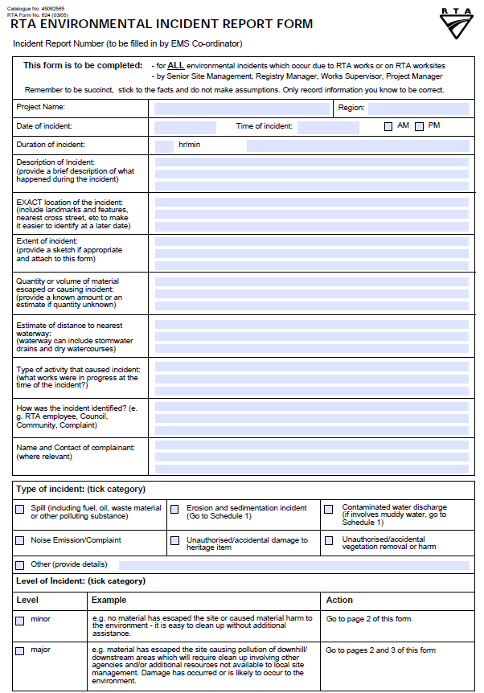

Source: http://www.rta.nsw.gov.au

Exercise 9

* Discuss the sustainability and efficiency consultation roles within your workplace and the processes they utilise to deliver and gather information.

|  |
| --- |
|  |
|  |
|  |
|  |
|  |
|  |
|  |
|  |
|  |
|  |
|  |

* Refer to the environmental legislation site that you identified in Exercise 2. Discuss any training programs that may be available to workplaces within your industry.

|  |
| --- |
|  |
|  |
|  |
|  |
|  |
|  |
|  |
|  |
|  |
|  |
|  |
|  |
|  |

* Discuss any external inspectors or officers that may visit your workplace. What tasks do they perform?

|  |
| --- |
|  |
|  |
|  |
|  |
|  |
|  |
|  |
|  |
|  |
|  |
|  |
|  |
|  |

* Create a reporting form that could be used to report environmental incidents within your workplace.

|  |
| --- |
|  |
|  |
|  |
|  |
|  |
|  |
|  |
|  |
|  |
|  |
|  |
|  |
|  |

Sustainability Policies

Another major documentation requirement of the sustainability committee is the creation of a sustainability policy. A sustainability policy outlines the requirements and expectations of the company and is used to communicate these intentions to staff and customers.

A formally documented sustainability policy can consist of three parts:

1. An official and public statement of the company's commitment to achieve sustainability objectives and protect the environment.
2. Clear specification of delegated responsibilities, monitoring and reporting procedures.
3. A plan to guide the identified sustainability practices and provide continuity.

A sustainability policy can also outline any targets that may have been set by the sustainability committee. When writing a sustainability policy, take the time to consider responses to the following:

1. What type of business are you in?
2. Why is sustainability important to your local environment?
3. What steps are you already taking to address sustainability and what do you have planned?
4. What would you like to have achieved 12 months from now?
5. Who is the main point of contact in your business?

8. How

Source: <http://www.tq.com.au>

The example on the next page is an excerpt from the Sustainability Policy document published by the University of Technology Sydney.

|  |
| --- |
|  |

Source: [www.green.uts.edu.au](http://www.green.uts.edu.au)

Exercise 10

* Discuss whether your workplace has a workplace sustainability policy in place.

|  |
| --- |
|  |
|  |
|  |
|  |
|  |
|  |
|  |
|  |
|  |

* Discuss the critical points within it, or the information that you would incorporate should one not be in place (you may need to undertake some research to assist you within this).

|  |
| --- |
|  |
|  |
|  |
|  |
|  |
|  |
|  |
|  |
|  |
|  |
|  |

Improvement Processes

As we have established, one of the main purposes of the sustainability committee is to gather information in regards to the current status of the workplace. This information is collected via tools and consultation processes to identify and implement improvements. It must again be raised at this point however that environmental, sustainability and efficiency improvement processes will in most cases come with some sort of cost factor involved. In fact, we have already identified that one of the major barriers to improvement is costs. Due to this, it is imperative that each identified improvement is properly researched and clearly explained and that change is not made simply for change sake.

Each prospective change should be analysed to ensure that the cost to the company does not outweigh the planned improvements. When dealing with improvements to sustainability processes within the workplace, the following steps can be undertaken:

* Identify areas of improvement
* Set targets
* Plan and implement the improvements

Improvement Identification

When attempting to identify possible environmental improvement strategies within the workplace, there are numerous areas that can be checked. The following list outlines some areas that can be analysed to identify areas of improvement:

|  |  |
| --- | --- |
| **Resource Usage** | During the efficiency measurement process, creditor invoices and manufacturer documents etc. are checked to identify where cost savings can be made. The risk here is that a simple check may find that there is a cheaper consumable option elsewhere. Careful assessment must be made to ensure that the current consumable, whilst more expensive, may not last longer and save on maintenance cost etc. An example is as follows:  **Electricity Usage**: Some electricity providers can supply a breakdown of when your workplace is using the most amount of electricity. If this is at peak times, some functions (batch print jobs, automated functions) may be adjusted to run out of hours to take advantage of off peak tariffs. Other electricity saving exercises include Installing energy efficient light fittings (more expensive than normal bulbs, but last much longer). |

|  |  |
| --- | --- |
| **Waste Management** | Due to legislative requirements (in order to protect our environment) waste management can be a rather expensive exercise. Even though you may not be able to change the way the waste is disposed of, you may be able to reduce the amount of waste that you create by:   * Utilising cleaner materials in production (again, more expensive but cost may be offset by reduced waste costs). * Implementing waste recycling processes such as only purchasing consumables packed in recyclable materials. * Checking re-use options (especially for water or oil based waste). |
| **Maintenance** | Due to the costs of labour and manufacturing downtime, many companies fail to have machinery or office equipment maintained within scheduled timeframes. Returning maintenance schedules to manufacturer guidelines may cost more in the short term, but can save costs in the long run via increased efficiency, reduced electricity or water requirements and decreased output of waste. |
| **Purchasing Strategies** | As with consumables, check invoices and purchase orders to ensure that all goods purchased are adequately energy rated. Remember, the higher the stars, the more energy efficient the product. |
| **Sales and Marketing** | Not all environmental strategies should come at a cost (although as we have discussed, some should only cost more in the short term). As environmental protection processes gain more and more public exposure, many companies include their own strategies as part of their own marketing campaigns. Some of these actions include:   * Inclusion in community environmental programs (Clean up Australia day for example). * Only selling and purchasing environmentally friendly products and packaging. * Sponsoring public events such as Eco-challenges etc. |

Exercise 11

* Refer to the information on the previous pages and discuss the usage and potential improvements that can be made within your workplace in the following areas.

|  |
| --- |
| Electricity usage |
|  |
|  |
|  |
|  |
| Waste Management |
|  |
|  |
|  |
|  |
| Maintenance |
|  |
|  |
|  |
|  |
| Purchasing Strategies |
|  |
|  |
|  |
|  |
| Sales and Marketing |
|  |
|  |
|  |
|  |

* In the last section of this manual, we discuss the usage and suggested improvements of electricity within the workplace. Discuss some other resources (water, fuel etc.) and discuss ways that these can be saved or used more efficiently.

|  |
| --- |
|  |
|  |
|  |
|  |
|  |
|  |
|  |
|  |
|  |
|  |
|  |

* Discuss any areas of improvement that you can identify within your own workplace that are not listed in this manual.

|  |
| --- |
|  |
|  |
|  |
|  |
|  |
|  |
|  |
|  |
|  |
|  |
|  |

Goals and Targets

Now, before we go running off and merrily improving the environmental practices of the workplace, we need to identify what it is that we are actually trying to achieve. In the previous section, we outlined some of the processes that we can undertake to identify potential improvements. Each improvement that we identify needs to be able to be measured for success.

Smart Goals

There are a number of ways that workplace goals and targets can be measured. The main points that must be accounted for however are that each suggested improvement can be effectively valued to measure the achievement of expected outcomes. One way to measure the effectiveness of goals is to ensure that they can meet the SMART criteria. SMART goals are goals that are:

* Specific
* Measurable
* Achievable
* Relevant
* Timely

Basically, by incorporating this method into our suggested improvement targets, we can ensure that we have the best chance of being able to measure their achievement. An example would be as follows:

*Target 1: To reduce printer power usage by 15% in three months by implementing power saving settings and running invoice batch processes overnight during off peak electricity tariffs*.

This target is specific in the steps that will be undertaken are relevant to their requirements, achievable and the outcomes can be measured at a pre-set timeframe. As each identified improvement is discussed, it should be analysed to ensure that a clear, measurable target can be attained and communicated to relevant committee and team members.

Exercise 12

* Refer to your answers to Exercise 11 and create some targets that could be utilised to manage your identified improvements.

|  |
| --- |
| Electricity usage |
|  |
|  |
|  |
|  |
| Waste Management |
|  |
|  |
|  |
|  |
| Maintenance |
|  |
|  |
|  |
|  |
| Purchasing Strategies |
|  |
|  |
|  |
|  |
| Sales and Marketing |
|  |
|  |
|  |
|  |

Implementing Improvements

Once the identified improvements have been set out and agreed upon, they can be implemented within the workplace. When proposing improvements to current processes, the following steps should be taken into account:

1. Ensure all relevant parties are familiar with the compliance report. For improvements to be made, everybody involved in the discussion process must be fully aware of what it is that they are trying to improve.
2. Check manufacturer guidelines. Some proposed implementations that outline the use of recycled equipment or consumables may void warranties or lead to extra maintenance costs to the company.
3. Ensure any identified improvements fit within company policies and protocols. Great care should also be taken to ensure that suggested improvements comply with all relevant legislations and acts. Purchase and supply contracts should also be checked to ensure that should a change of product be recommended, these contracts are not breached.
4. Undertake a cost analysis. As with OH&S improvements, some changes to the environmental processes of a workplace can actually increase the cost of trade of the company. A cost analysis should identify whether the increased cost versus the expected improvement outcomes are cost effective.
5. Consult with applicable team members or managers. In some cases, changes in the name of efficiency may actually slow down the task at hand. Team members who are familiar with each task may be able to identify areas of concern that have not become evident during the original audit process.
6. Plan your measurement processes. We have already covered the importance of setting a baseline and SMART goals. It is critical that we ensure that we are able to measure any improvements that have been identified. If a change is implemented and it is unable to be measured, you will not be able to identify whether the change is worthwhile or simply change for change sake.

Once a set of improvements have been identified and the checks listed above undertaken, carefully planned strategies need to be undertaken to actually implement the changes. These may include:

* New purchasing arrangements
* Changes to products utilised
* New waste management processes
* Administrative or process changes
* New equipment
* Configuration changes (power management settings etc.)
* Changes to equipment servicing arrangements

These changes however are not going to implement themselves. Effective change management processes need to be undertaken to ensure that the implementation process is run efficiently and without causing unacceptable levels of interruption to workplace members or tasks. Simple change management steps could be undertaken as follows:

|  |  |
| --- | --- |
| Step 1 – Define the change. | This is the most critical and most often the most missed step of any change management process. This step involves creating a clear outline of what it is that is actually being changed. The change may not be large (such as changing the type of chemicals that are used), hence, neither does the outline. It may simply be: “*The change involves ceasing the use of XXX cleaning chemical and introducing YYY cleaning chemical in its place”.*  This statement not only outlines what is to be changed, but also what is NOT being handled as any other changes should be handled under a separate process. |
| Step 2 – Identify roles and responsibilities | This step requires the identification all team members that will be affected by the change. Even though we may not be fully aware of how or when we are going to make the change, we still need to know who is going to plan, implement and manage the change process. |
| Step 3 – Plan the change | We have already identified who is responsible for the change in step 2. Step 3 involves the detailed planning of how and when the change is going to be implemented. A clear concise action plan is required including:   * The sequential steps required to complete the change * A completed schedule of who and when the changes are to be made including measurable outcomes for each step * How the change requirements will be communicated (to ALL team members, not just those affected) * A back out plan should the change process fail or run into unacceptable problems * Steps for ongoing management of the change * Measurement and reporting steps to be undertaken |

|  |  |
| --- | --- |
| Step 4 – Implement and monitor the change | The manager who is responsible for the change then implements that plan and makes the change. Each step should be carefully monitored to ensure that the planned outcomes or targeted timeframes are met. |
| Step 5 - Evaluate and Report the change | Once completed, the entire change process needs to be analysed and a report created outlining the entire process. In most cases, the report will include:   * Whether each step of the change process was completed sufficiently * An outline of what worked well and what could be improved on * Whether the change was successful * Ongoing monitoring processes to check success |

Exercise 13

* Use the step guides on the previous pages to create a change plan for one of the efficiency improvements identified in Exercise 11.

|  |
| --- |
|  |
|  |
|  |
|  |
|  |
|  |
|  |
|  |
|  |
|  |
|  |
|  |
|  |

* Discuss your plan with your group supervisor the steps you would take to monitor your changes.

|  |
| --- |
|  |
|  |
|  |
|  |
|  |
|  |
|  |
|  |

* Create a checklist that could be utilised to assist with the implementation process.

|  |
| --- |
|  |
|  |
|  |
|  |
|  |
|  |
|  |
|  |
|  |
|  |
|  |
|  |
|  |
|  |
|  |
|  |
|  |
|  |

Managing Information

As the sustainability committee undertakes its processes of identifying and implementing changes, it is important that ongoing information is available to team members. Sustainability documentation is not only critical to the ongoing prevention, identification, reporting and analysis of potential environmental issues in the workplace but a very effective tool in assisting with the meeting of targets. The Sustainability Officer is required to ensure that any documentation to do with workplace efficiency standards, compliance requirements, procedures or legislation changes is released into the workplace as required.

The types of documentation required can be many and varied and can include:

* Graphical representations of company targets
* Memos outlining legislation updates and hazards identified
* Instruction guides
* ‘Reminder’ flyers and notices
* OH&S contact lists (for spills etc.)
* Induction manuals
* Risk and Hazard assessment forms and identification reports
* Equipment usage procedures manuals

When policies or equipment changes occur, these documents need to be updated and re-issued regularly to all employees. Information can be delivered in many ways, including:

* Bulletins on workplace noticeboards
* Information posted on the company Intranet
* Information in lunchrooms or the canteen
* Notices supplied with staff induction materials
* Team meetings
* Training sessions
* Daily briefings

The example on the following page outlines some ideas that could be included on a "green" bulletin board within a public school system.

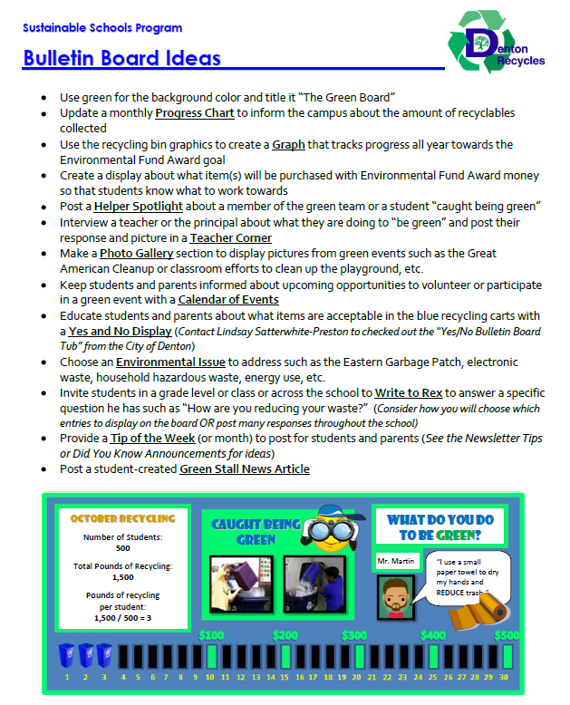

Source: [www.cityofdenton.com](http://www.cityofdenton.com)

Providing Documents to Workstations

In many cases, environmental efficiency information can be distributed to all employees of an organisation via the relevant placement of documentation. Information specifically related to a workstation, piece of hardware or task can be posted as a reminder of sustainability and efficiency practices that are required to meet environmental targets. This includes information related to:

* Computer equipment – e.g. Reminders to shut down or power off when not in use or when to replace ink cartridges etc.
* Manufacturing equipment – information in regards to checking for environmental issues such as oil (or other liquid) spills etc.
* Maintenance – Maintenance record sheets posted on or near relevant equipment.

As with all documentation, when policies or equipment changes occur, these documents need to be updated and re-issued regularly to all employees.

Changing Documentation

Due to the importance of adherence to legislation and industry standards when it comes to the creation and publication of environmental documentation, many companies implement strict guidelines when documentation changes are required. Inaccurate or invalid documentation can cause extreme detriment to a company including compliance breaches, increased cost to the company, damage to reputation and/or legal action. Whenever a change requirement is identified, the following processes are often followed:

|  |  |
| --- | --- |
| **Confirm information** | The change information needs to be confirmed prior to it being added to any documentation. This information can be found in:   * Environmental governance websites * Industry publications * Manufacturer guidelines or publications * Media releases * Other company documentation |
| **Implement documentation changes** | Implement changes to the documentation as per company guidelines and processes. When changes are made to documentation based on legislations and standards, edited documents should be saved in new files and obsolete files preserved. This process is called version control and allows previous documents to be re-visited should future issues or actions occur. |

|  |  |
| --- | --- |
| **Submit changes for signoff** | As stated, the publication of inaccurate information can have severe ramifications in the workplace. Prior to publication of the new documents, it is important that any company signoff processes are strictly adhered to. In many cases, a signoff sheet is signed by appropriate parties and filed as per company policies. |
| **Publish to workplace** | Remove all copies of out-dated documentation from the workplace and replace with new postings. Ensure a copy of the removed documentation is saved as part of the version control process. |
| **Advise workplace** | Many staff members do not check environmental sustainability documentation on a daily basis. Advice of documentation changes needs to be actioned as part of the update process. This can be achieved by:   * Email * Memo * Team meeting agenda item * Public Notice on noticeboard * Advertisement on company intranet site |

Exercise 14

* Discuss the processes and responsibilities for disseminating sustainability and efficiency information within your workplace.

|  |
| --- |
|  |
|  |
|  |
|  |
|  |
|  |
|  |
|  |
|  |
|  |
|  |

* How are changes to this information managed?

|  |
| --- |
|  |
|  |
|  |
|  |
|  |
|  |
|  |
|  |
|  |
|  |
|  |

* Discuss any suggested improvements with your group/supervisor.

|  |
| --- |
|  |
|  |
|  |
|  |
|  |
|  |
|  |
|  |
|  |
|  |
|  |
|  |
|  |
|  |

* Refer to the example of possible 'green board' ideas on page 52 of this manual. Discuss which of those ideas would be effective within your workplace.

|  |
| --- |
|  |
|  |
|  |
|  |
|  |
|  |
|  |
|  |

* Choose one of your ideas listed above and create as example.

|  |
| --- |
|  |
|  |
|  |
|  |
|  |
|  |
|  |
|  |
|  |
|  |
|  |
|  |
|  |
|  |
|  |
|  |
|  |
|  |

Continuous Improvement

Just because we have a target and plan in place does not mean that we are done. Just as OH&S safety officers are required to undertake continuous checks to ensure that their workplace is safe, so too do sustainability officers also need to maintain the standards as set out by the committee. Each process must be continuously monitored to ensure that:

1. It is meeting the targeted measurable outcomes that have been set.
2. It is continuing to meet compliance regulations in a changing environment and through updated legislations.
3. Any further improvements are identified and reported.

Once the change has been implemented, we need to revisit that baseline and monitor over a set amount of time to ensure that the change has actually worked and the expected improvements have been realised. Perhaps the most important reason for this process however is to ensure that the compliance status of the workplace is maintained.

Monitoring Environmental Behaviour

The task of monitoring environmental, sustainability and efficiency changes can be split into three main areas:

|  |  |
| --- | --- |
| **Check that the change has been actually made.** | This may be simply checking that the change has been made such as whether the cleaning staff using the new chemical for their daily tasks. Other checks can include:   * That equipment maintenance schedules have been created (see example on next page). * That after hours batch processing configurations have been made. * New purchasing agreements have been put in place. |
| **Undertake Audits** | Earlier in this manual, we discussed the processes required to check the current sustainability status of the workplace. This part of the monitoring process simply entails repeating the steps that were taken at that time.  As each audit step is completed, the results should be compared to previous undertakings and baselines to ensure that the expected improvements have been made. |

|  |  |
| --- | --- |
| **Check financial statements or bills** | If the changes are designed to reduce resource consumption (electricity, water, fuel etc.), then a simple check of incoming bills or statements can identify if they are less than the previous statement period.  ***Note****: Simply checking that the amounts are less may not be sufficient. Other influences such as public holidays, factory shutdowns or staff absences can also influence commodities bills and resource use.* |
| **Check Legislations** | One other check that is of critical importance is continuous research into the environmental legislations that influence the workplace. Should any aspect of this change, sustainability and efficiency processes that are in place may need to be revisited even if they are in fact effective. Should these steps not be undertaken, the workplace may risk the issue of a non-compliance breach notice. |

The example below is of a Maintenance Sheet that could be utilised to ensure that each requirement is met.

|  |  |  |  |
| --- | --- | --- | --- |
| **Items to be Maintained** | **Frequency of Maintenance** | **Maintenance required** | **Who will perform Maintenance?** |
| *Printer* | *Monthly* | *Dust removed from printer heads.*  *Ink track and print heads cleaned* | *IT Officer* |
| *CPU* | *Six Monthly* | *Grease removed from fans*  *Dust Removed from CPU and motherboard* | *Supplier* |
| *Power Generator* | *Monthly* | *Oil Changed*  *Seals Checked*  *Fuel cleaner added to tank* | *Manufacturer* |

Resetting Targets

As each sustainability and efficiency practice is monitored and audited, the results should be reported back via the sustainability committee for appraisal. Each result should then be checked against the original compliance and efficiency targets to ensure that the methods put in place have been effective. Should the results come up short, then the following steps could be undertaken:

1. Check the audit results to ensure accuracy of data.
2. Re-check target goals to ensure that required outcomes met the relevant goal setting criteria.
3. Ensure that workplace processes or legislative requirements have not changed.
4. Ensure that staff members have been fully informed and are accepting of the implemented changes.

Should any of the steps above prove that the targets are either unachievable or cannot be reached due to the fact that workplace processes or legislations have changed, it may be necessary for them to be reset. In order to achieve this, the committee must revisit all aspects of the required outcomes including:

* The original status
* Suggested changes
* The original target and its measurables
* How the required target outcomes were monitored
* What the difference is between the expected and current outcomes
* Any reasons for the shortfall

One common mistake that is often made is that sustainability and efficiency targets are reset but not properly released into the workplace. It is essential that the implementation processes that we have outlined are restarted and followed as per a new improvement protocol.

Rewarding Staff

So far, we have covered the steps to be undertaken should workplace sustainability goals and targets not be met. Should the monitoring process identify that the targets have in fact been achieved, some workplaces as part of their continuous improvement processes incorporate a rewards program to contributing staff members. These rewards can be used as not only a 'thank you' for their contributions to the cause, but also as a means of maintaining motivation for the next target that is set (because we are certainly not going to rest on our laurels now are we?).

Exercise 15

* Refer back to your answers and discussions in Exercises 11, 12 and 13 and outline the checks that you would undertake to monitor the changes that you have identified for your workplace.

|  |
| --- |
|  |
|  |
|  |
|  |
|  |
|  |
|  |
|  |
|  |
|  |
|  |
|  |
|  |

* Create a checklist that could be utilised to assist with the monitoring process.

|  |
| --- |
|  |
|  |
|  |
|  |
|  |
|  |
|  |
|  |
|  |
|  |
|  |

* Refer to the maintenance checklist on page 58 of this manual. Use the example below to add maintenance requirements relevant to your workplace.

|  |  |  |  |
| --- | --- | --- | --- |
| **Items to be Maintained** | **Frequency of Maintenance** | **Maintenance required** | **Who will perform Maintenance?** |
|  |  |  |  |
|  |  |  |  |
|  |  |  |  |

* Discuss the processes that you would undertake should your monitoring steps identify a shortfall against intended outcomes.

|  |
| --- |
|  |
|  |
|  |
|  |
|  |
|  |
|  |
|  |

* What steps would you undertake should targets need to be reset to re-attain workplace compliance?

|  |
| --- |
|  |
|  |
|  |
|  |
|  |
|  |
|  |
|  |
|  |

* Discuss any rewards programs that could be introduced should sustainability targets be achieved?

|  |
| --- |
|  |
|  |
|  |
|  |
|  |
|  |
|  |