Fully blocked Open Punctuation Letter

What is a fully blocked open punctuation letter?
With fully blocked open punctuation letters, every section of the letter begins on the left hand margin, and all paragraphs are separated with a blank line(s). Punctuation is only used in the body of the letter, nowhere else (such as the address blocks and salutation).

Sections of a Letter

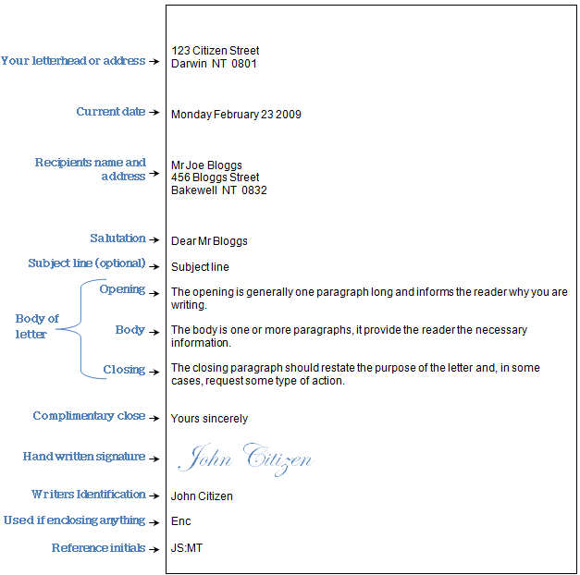

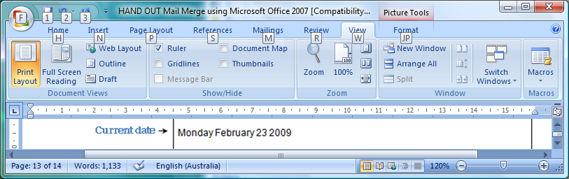

NOTE: If you have used Sir/Madam in the salutation, use Yours faithfully.

Letter Spacing
NOTE: Only include reference initials if 2 people worked on the letter writer’s initials : typist initials.
NOTE: If using a letterhead, allow 8 - 10 lines from the top of the document to accommodate the letterhead.

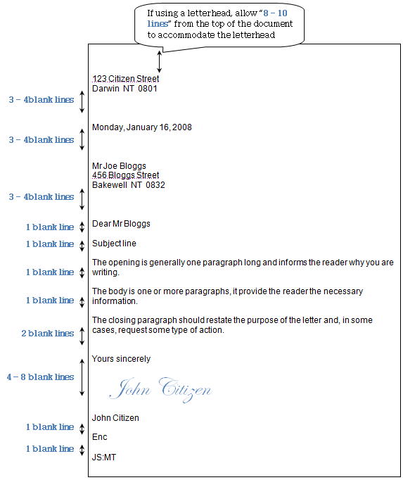

If using a letterhead, allow “8 - 10 lines” from the top of the document to accommodate the letterhead

