Using the Text Tool

Step 1 - Create an image 500 pixels x 500 pixels.

Step 2 - Select the text Horizontal Type Tool.
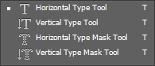

Step 3 - Select the text style and text size as illustrated below.
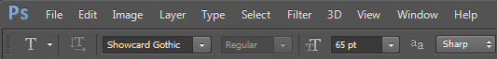

Step 4 - Click in the middle of your image and enter the text PHOTOSHOP.  Cancel or commit current edits  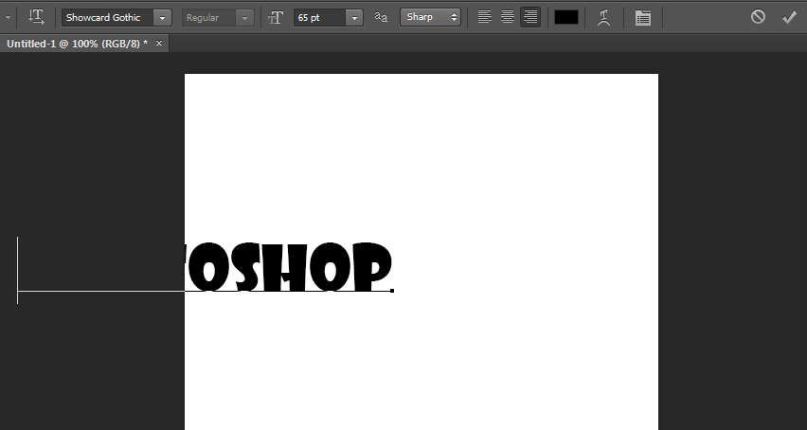 | You will notice that your text is not fully positioned on your image, don’t worry about it now.  Click the tick to commit your current edits.  Once you have committed your current edits, use the Move Tool to reposition your text in the middle of your image.  Note you have created a new Text Layer.  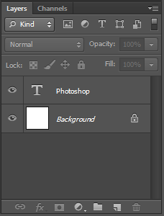  Text Layer

Step 5 - Edit your existing text in the Text Layer to read MY PHOTO instead of PHOTOSHOP, and change the text colour to red.  To accomplish this you need to first of all make sure your Text Layer is selected, and then select the Horizontal Text Tool. Now select your text and make the required changes. | 
Set your text colour to red and commit. You will now notice that your Text Layer has been renamed. | 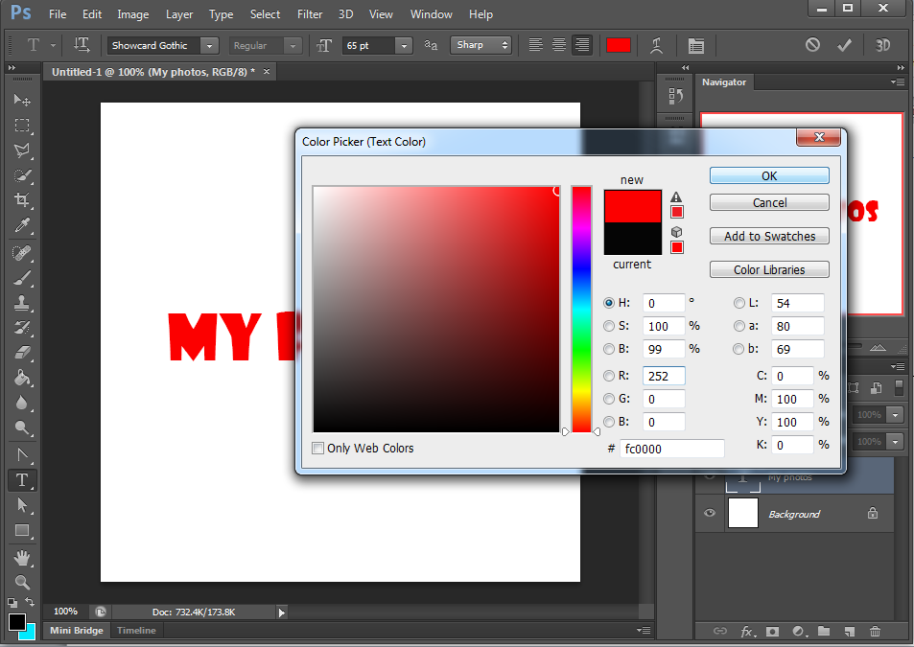  Set text colour  
Step 6 – Warp the existing text in your Text Layer.  To accomplish this you need to first of all make sure your Text Layer is selected, and then select the Horizontal Text Tool. Now select the Create warped Text Tool. | 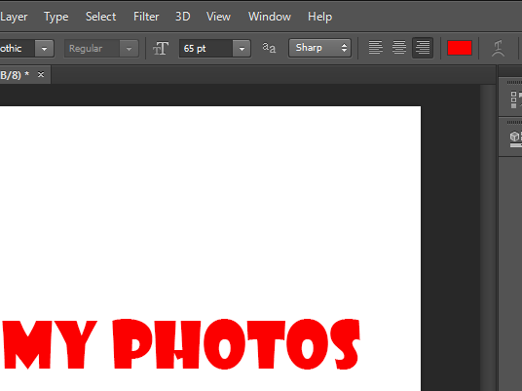  Create warped text
Select the Twist style, and change your Bend, Horizontal Distortion and Vertical Distortion parameters. Finally click OK to accept the changes. | 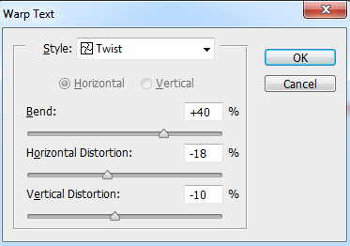

Using the Text Mask Tool

Step 1 - Create a new layer and name it Text Selection.

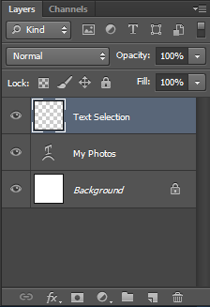
An easy way to create a new layer – Click the Create a new layer icon.

Step 2 - Hide the My Photos Layer.

Step 3 - Make sure your Text Selection Layer is selected and select the Horizontal Type Mask Tool.

Step 4 - Select the text style and text size as illustrated below.
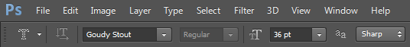

Step 5 –Enter the text COMPUTER, and commit


Once committed you will notice you have created a text selection. The text within the text selection cannot be edited.


Step 6 - Using the Pain Bucket Tool colour your text selection.


Step 7 - Using the Paint Bucket Tool colour your text selection.  Step 8 - Add a drop shadow to your text selection.  To add a drop shadow select Layer - Layer Style - Drop Shadow (as illustrated below).  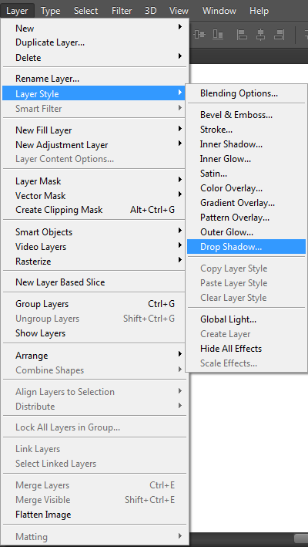 | Once you have selected the Drop Shadow option the Layer Style window will appear. From here you can set the properties of your shadow. For the sake of this exercise accept the default values.  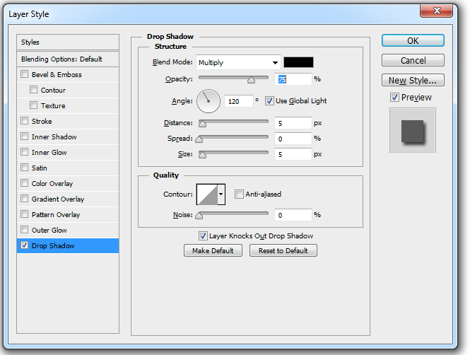  

Deleting Layers

To delete a layer simply drag and drop the layer into the Delete Layer Bin.

Delete all layers.
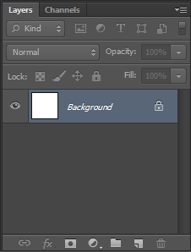
Delete Layer Bin

Using the Gradient Tool

Step 1 - Create a new layer and name it Circle.  Step 2 - Select a Foreground and Background colour of your choice.  Step 3 - Create a selection of your choice.  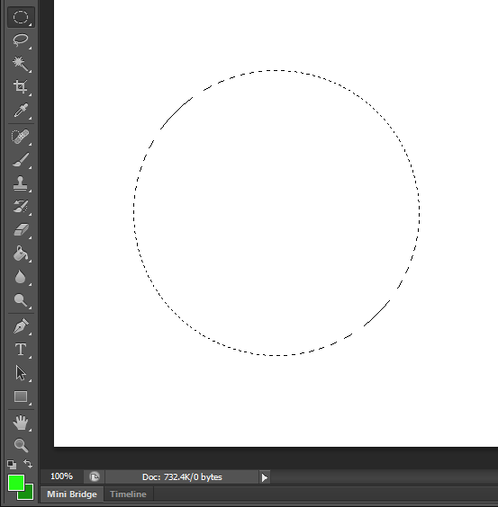  Foreground and Background colours | Steps 4 - Using the Gradient Tool add a gradient to your selection.  To add a gradient click on the part of your selection you want the foreground colour to commence, then drag and drop into the position you want the background colour to finish.  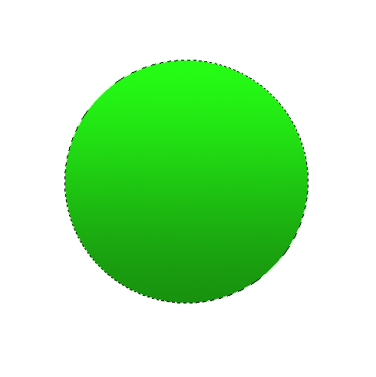  Try using the Shift key when using the drag and drop feature to create the gradient colour.

Steps 5 - Create another layer and name it Text. Hide the Circle layer.

Steps 6 - Using the Horizontal Type Mask Tool with the given text properties enter the text ABC.

Position your text (using the Move Tool) in the middle of your layer.

Steps 7- Using the Gradient Tool with colours of your choice, add a gradient to your text. You may want to use a present gradient from the gradient picker.

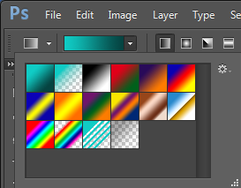
Gradient Picker

Steps 8- Unhide your Circle layer.



Exercise
Using 2 layers and the skills you have learnt, create the sunset graphic illustrated below.
Save your logo as a psd file.

Using the Pen Tool
Note: The following task will be demonstrated in class.

Step 1 - Create a new layer

Step 2 - Select the Pen Tool and create a circle following the instructions below.

Create a circle with 4 points given the following steps.  4  1  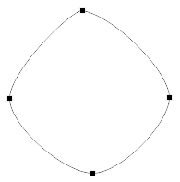  2  3 | Click into position 1, drag and drop to create you’re your anchor points.  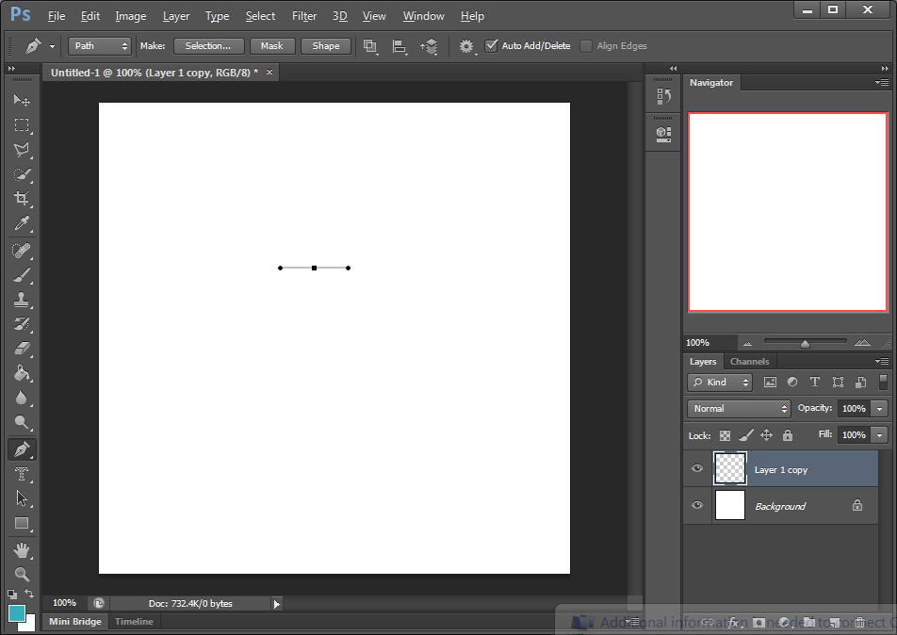 |  | Click into position 2, drag and drop to create you’re your anchor points.  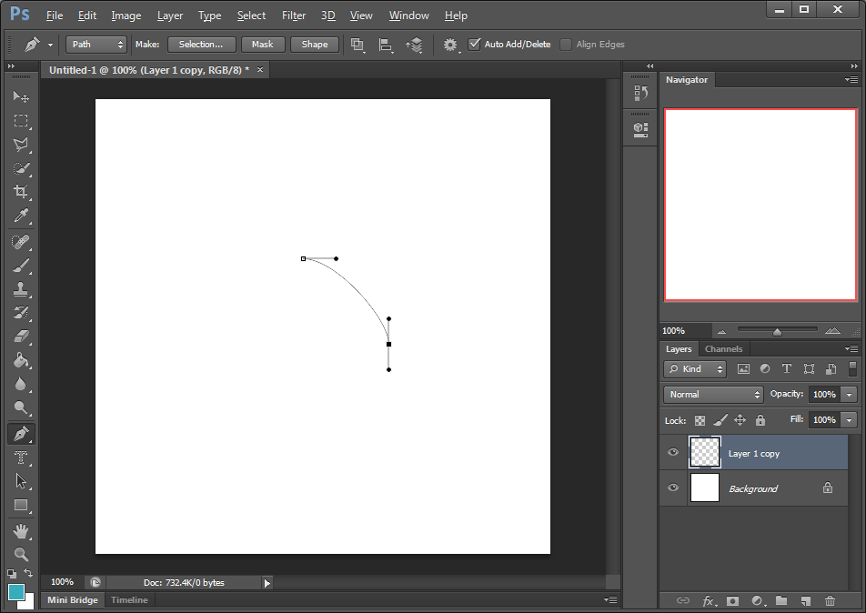
Click into position 3, drag and drop to create you’re your anchor points.  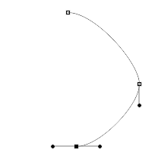 | Click into position 4, drag and drop to create you’re your anchor points.  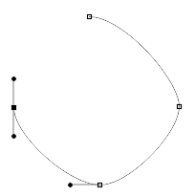 |  | Click back into position 1 to complete the circle.  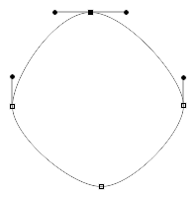
Step 3 - Select the Direct Selection Tool and attempt to smooth out the circle.  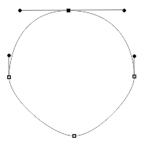  To smooth out the circle, click on each individual point and work the anchor points, watch the class demonstration. |  | Step 4 - Once you have worked all your anchor points, right click on the circle and select Make Selection - New Selection.  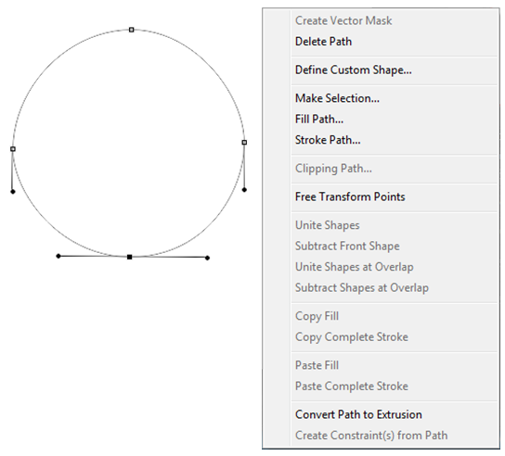  Make Selection
Step 5 - Add a gradient to the selection (circle) created above.

Exercise
Using the skills you have learnt; create the leaf graphic illustrated below.


Additional tools you may find useful include:
- Add Anchor Point Tool
- Delete Anchor Point Tool
- Convert Point Tool

