ICTWEB303 – Produce digital images for the web

Session 2

Image Stock
Image stock is another term for image libraries which are available to the public. You can view and use all kinds of images for any specific subject, but usually for a fee.
The benefits of using image stock are that you have access to vast amounts of high quality images and photography at the click of a button. This saves time when existing professional imagery is not available.
The quality of the imagery is usually of a very high standard and usually available in many different resolutions and for multiple purposes.
There are many different image stock websites available, but for this session we will concentrate on iStock - http://www.istockphoto.com/.
Enter a topic or subject into the keyword field, and the results will pictures which match your keywords.
All stock photo sites have some form of licencing for the use of their image and you will need to understand how each site’s pricing structure works and for what usage type.
Pay particular attention to the different costs for different resolutions. You can also do advanced searches based on many differing criteria.

Copyright
The copyright for images on the web is the same as any other copyright laws within Australia. (http://www.copyright.org.au/)
Essentially, copyright is the ownership of something, in this instance, web photography and images. If you create an image from scratch, and it’s from your own ideas, then you or the company you are working for own the copyright for that image. Of you own the copyright of an image, then you can authorise how and when the image is used or you can sell its use to other businesses.
Copyright is closely associated to trademarks in regards to logos. You must be careful when designing a logo that it does not infringe on another person or organisation’s registered trademark(s).
You can check trademarks using the ATMOSS trademark database from the Australian government organisation Intellectual Property Australia. (www.ipAustralia.gov.au).

Image editors
There are many different image editors available. Some are stand alone applications and some are web based. Some cost thousands of dollars some are free. What you should be looking for is for the image editor to be able to do the things you want to do. For simple cropping or adding text to an image, there are many free applications and apps available to do this. For more complex tasks there and applications which are more suited, some being free and most costing some amount of money.
As it has been identified by the industry leaders and creators of these applications that their costs are far too expensive for most users, they now offer monthly subscriptions for full versions of their applications for as little as $50 per month (for the Master collection of the Adobe suite or applications – Dec 2013)
This initiative also combats the piracy of these applications.
Industry standards with the use of various applications changes over time. In the past, Corel Draw was a main player in this field, not so much anymore. Do some research, and see what the application of choice is for your purpose.
Here is a very brief rundown of four imaging application, but there are hundreds of others out there as well.

Photoshop
Raster based imaging software suitable for photographic restoration and web images.

Illustrator
Vector based imaging software suitable for logo creation, magazine work and layouts etc.

Paint Shop Pro
A cheaper application which has been on the market for years based off Photoshop.

GIMP
A free raster based imaging application which is open source and capable of quite advanced imaging techniques.

Photoshop
The application we will use for this class is Adobe Photoshop. This application is a leading industry standard for web image creation. A 30 day trial version of this software can be downloaded from www.adobe.com which should give you sufficient time to complete this unit.
Photoshop has three main advantages over other software which in some cases have exactly the same tool; Photoshop was the first to market with layers and selections. Photoshop also has an extensive array of filters and many more can be added on.

Using Photoshop
To use Photoshop, you first need to have a run down of the basic tools which we will be using.
Once you open Photoshop up, you will notice a toolbar on the left hand side. To be able to use these tools, we must first create a new document to experiment with.

Creating a new document.
>File >New
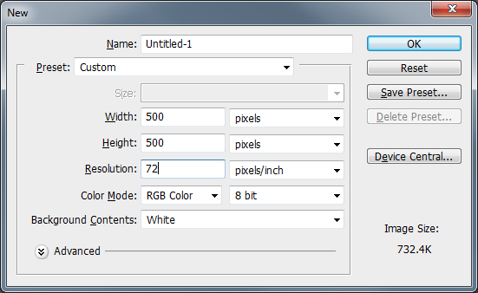
And you should result with something like below:
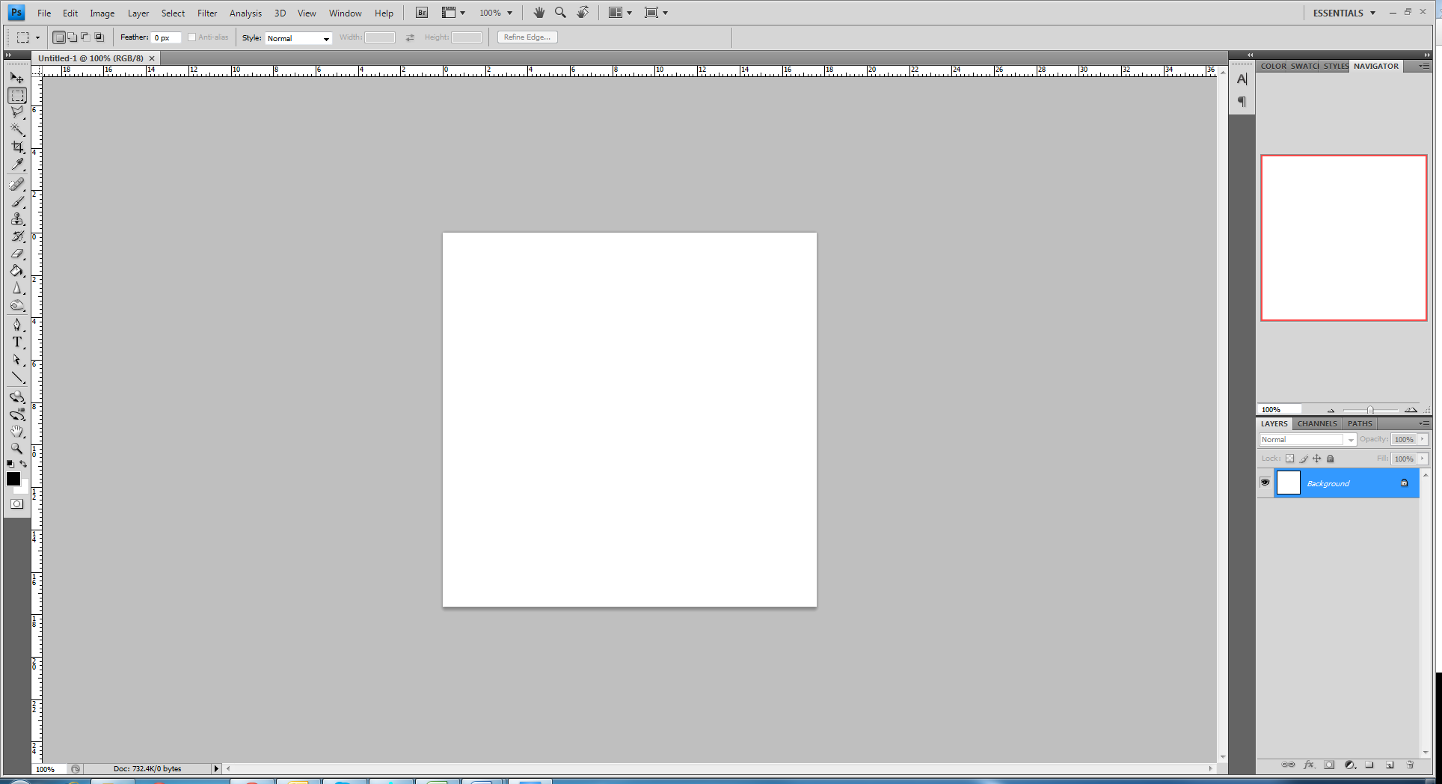
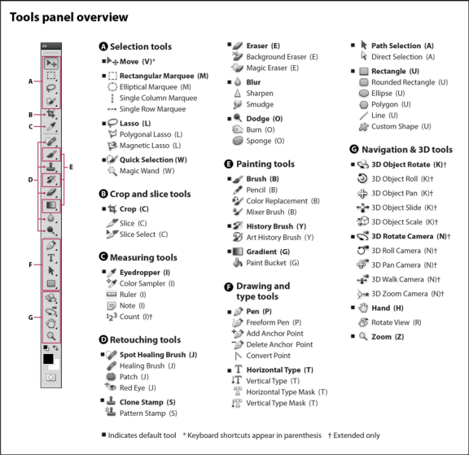

Selections

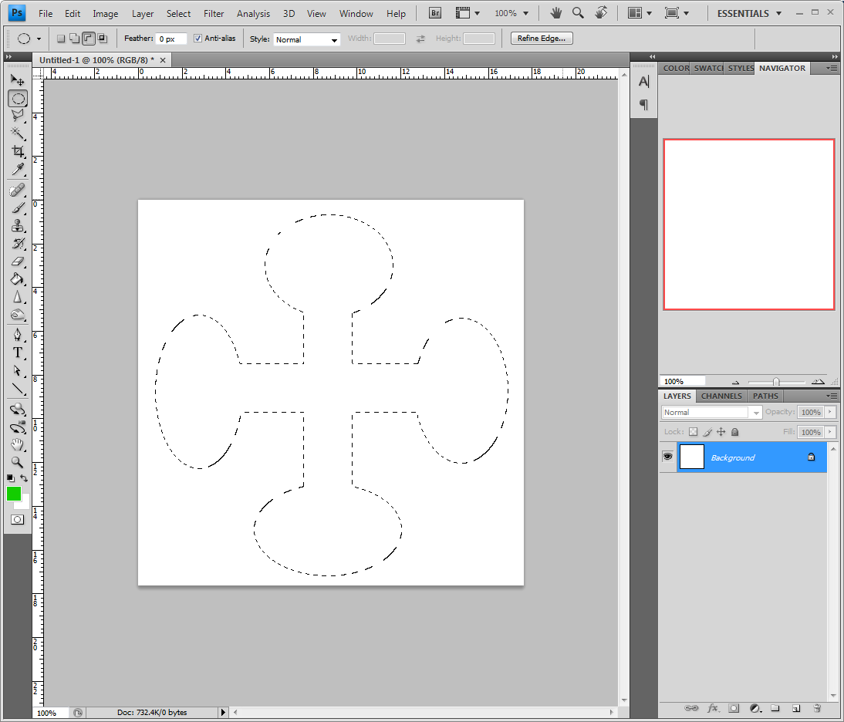

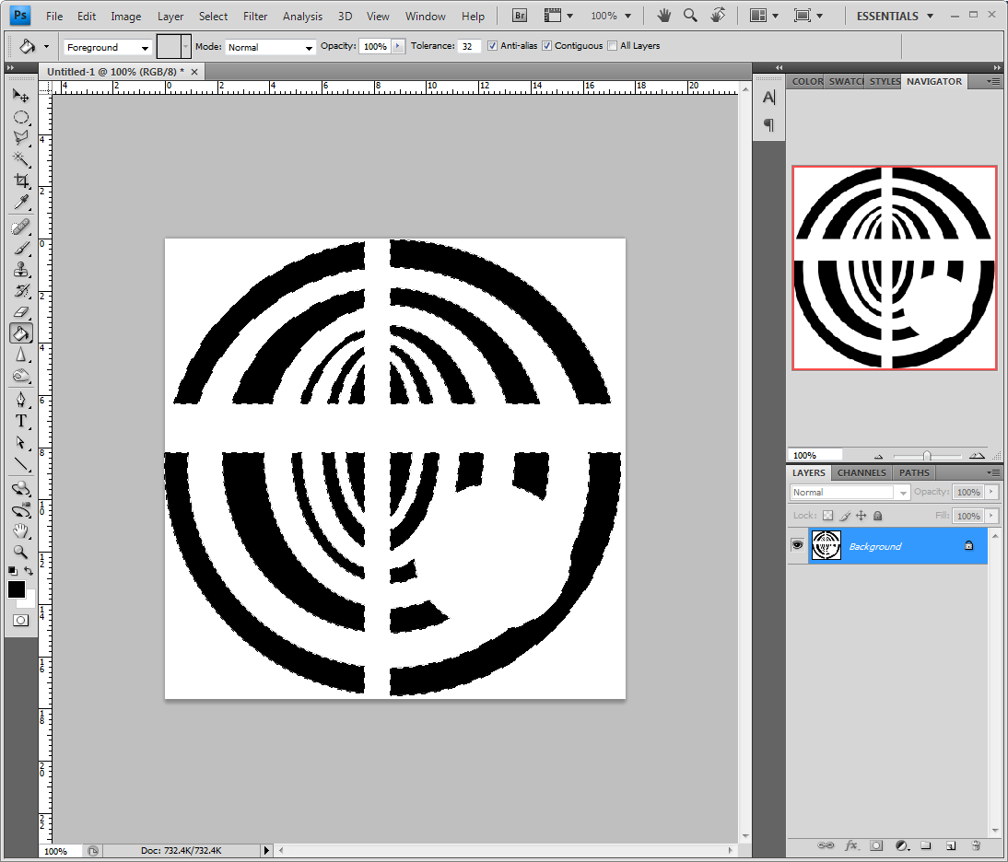

Layers and Selections.

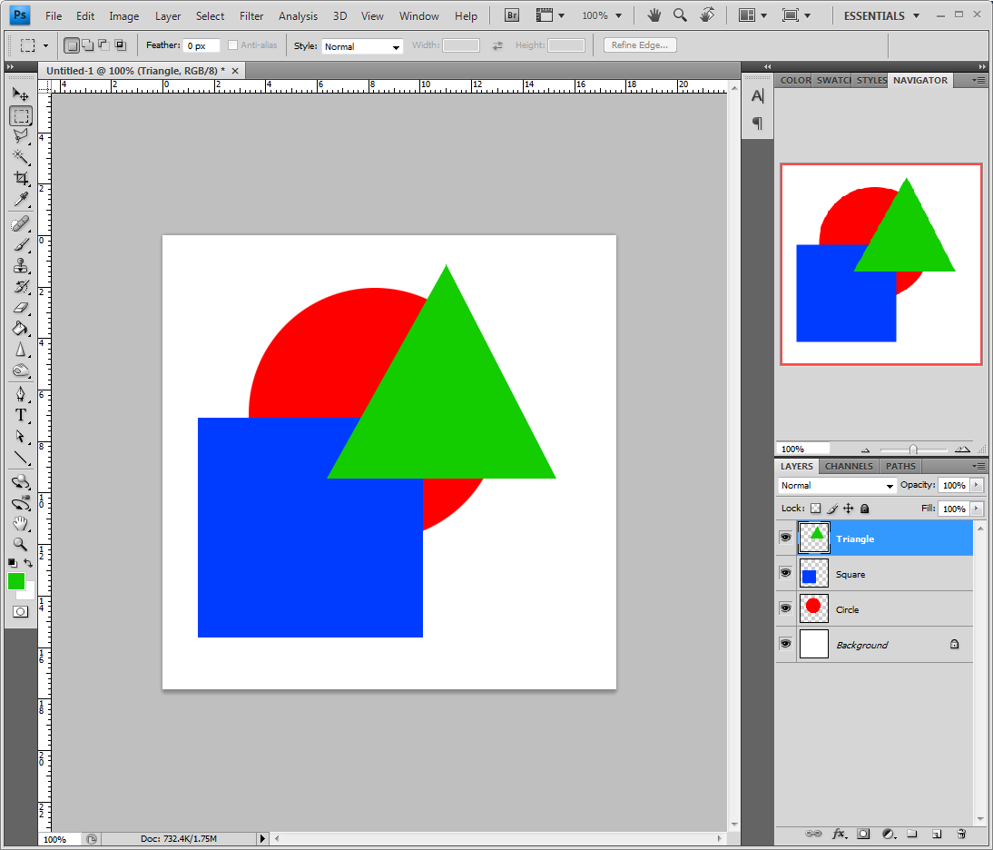

Saving Images
With Photoshop you can save images the usual way by going to >File >Save and from there you can select the location you want to save the image and the format, but Photoshop also offers a really cool “Save for web” option when saving >File >Save for web & Devices.
This option then allows you to save your image in the best format for the web. You can compare version of your image in different formats and different compressions. This is a very useful tool when creating web images as file size directly affects download times and you are aiming for the fastest download possible of any web graphic.
The trade-off is quality. The more image quality, the larger the file size. You should be aiming to reduce an image’s quality to the point just better than when you can actually notice quality degradation. This would be the best option when saving. Also remember that a PNG24 will always save an image with a larger file size than a JPG – but the JPG cannot render opacity.

